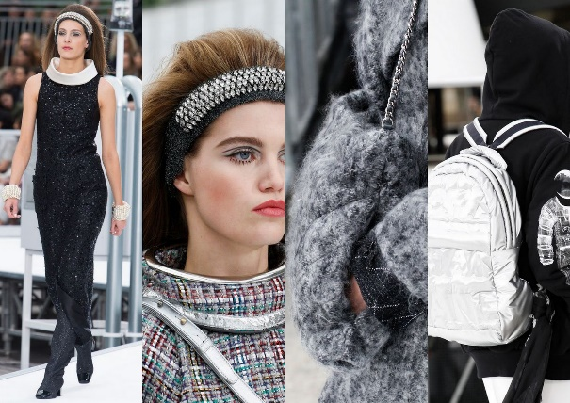
Transition work
Fashion & Textiles 2023
Read
What Is Fast Fashion and Why Is It So Bad? - Good On You
Announcing our major new Gabrielle ‘Coco’ Chanel exhibition • V&A Blog (vam.ac.uk)
Be prepared to discuss it in September.
Watch
The sewing Bee, BBC iplayer episodes, 1 and 4
BBC iPlayer - The Great British Sewing Bee - Series 9: Episode 1
BBC iPlayer - The Great British Sewing Bee - Series 9: Episode 4
Produce
You will need to purchase A4 sketchbook
- Investigate one of the following design styles and produce at least a double page in your sketch book on it. It can be computer or hand generated.
Art Deco, Art Nouveau, Pop Art, Punk,
- Investigate the clothing worn by women to the races and produce an annotated double page mood board on your favourite outfits, think about hair and shoes too!!!!!#
- Produce a double page of designs for skirts to be worn at the races based upon your chosen design style. Ensure that they are fully annotated.
Assessment
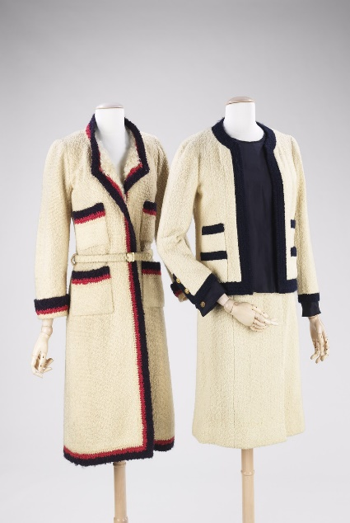
You will be assessed in a written question on your ability to describe your chosen design style and how it fits into the era that it was popular.
This Photo by Unknown Author is licensed under CC BY-NC

