The Transition to A-Level Chemistry
  - WKGS
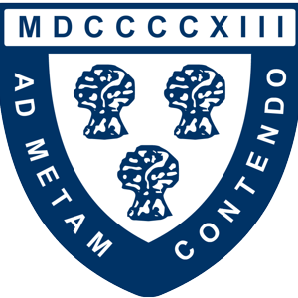
Mr. M Woods / mwoods@wkgs.net

Introduction
Many students find the transition from GCSE to A-Level Chemistry a challenging one. This booklet aims to make that transition smoother and to give you the best possible start in September.
It is important that you read through all the information carefully. This booklet contains material such as:
- Course information
- Books recommended to support your learning on the course
- Books recommended for wider reading
- Websites you will find useful throughout the course
- Videos that will help to promote a curiosity in the subject
- A wide range of activities and resources to ensure that your GCSE knowledge needed for A-Level is secure

Contents

Course information – Page 3

Recommend Resources to Support Your Learning – Page 7

Recommended Wider Reading – Page 9

Recommended Videos – Page 11

Preparation for A-Level Chemistry – Page 12 - 22

Task 1 – Atomic Structure – Page 13

Task 2 – Writing Chemical Formulae – Page 14

Task 3 – Chemical Equations – Page 16

Task 4 – Ionic Equations – Page 18

Task 5 – Amount of Substance Calculations – Page 20

Task 6 – Structure & Bonding – Page 22

Task 7 – Organic Chemistry – Page 23

Answers – Pages 24 - 31

Course Information

Introduction, exam board and course content
This course will suit any student with a genuine interest and enthusiasm for all that is around them; it will provide a firm scientific foundation for those wanting to make their mark in the world of science and technology in the future. You will develop practical, analytical and problem-solving skills through regular practical work. These skills are invaluable, universally accepted and highly sought after by universities and employers.
The course itself is AQA A-Level Chemistry and it is split it to three different disciplines, with each discipline containing several different topics.

- Physical Chemistry
- Atomic structure; Amount of substance; Bonding; Energetics; Kinetics; Chemical equilibria, Le Chatelier’s principle and Kc; Oxidation, reduction and redox equations; Thermodynamics; Rate equations; Equilibrium constant Kp for homogeneous systems; Electrode potentials and electrochemical cells; Acids and bases

- Inorganic Chemistry
- Periodicity; Group 2 - the alkaline earth metals; Group 7(17) - the halogens; Properties of Period 3 elements and their oxides; Transition metals ; Reactions of ions in aqueous solution

- Organic Chemistry
- Introduction to organic chemistry; Alkanes; Halogenoalkanes; Alkenes; Alcohols; Organic analysis; Optical isomerism; Aldehydes and ketones; Carboxylic acids and derivatives; Aromatic chemistry ; Amines ; Polymers; Amino acids, proteins and DNA; Organic synthesis; Nuclear magnetic resonance spectroscopy; Chromatography

Assessment
If you choose to take Chemistry as an AS you will sit two written papers of 1 hour and 30 minutes at the end of Y12. Paper 1 will assess content from the Inorganic and Physical topics and Paper 2 will assess content from the Organic and Physical topics.
For the full A-Level, there will be three written papers of 2 hours each. Paper 1 will assess content from the Inorganic and Physical topics, paper 2 will assess content from the Organic and Physical topics and paper 3 will assess content from across the entire course.
20% of the overall assessment for A-Level Chemistry will contain questions which assess your mathematical skills.
At least 15% of the overall assessment for A-Level Chemistry will assess knowledge, skills and understanding in relation to practical work.

Practical Assessment
No Chemistry course would be complete without practical work and you will carry out many practical experiments to aid your understanding throughout the course. Similar to GCSE, some of these practical activities will be classes as ‘required practicals’. The methods and theory behind these practicals can be assessed in your A-level examinations.
Unlike GCSE, however, you also be assessed on your performance during these practicals and the subsequent practical write-ups. This will be done using the CPAC system.
There are five CPAC (Common Practical Assessment Criteria) skill areas that students are assessed in over the two years. Each student will have the opportunity to master each skill area and gain a pass which will be on their A-level examination certificate. The skills areas are:
- CPAC1 – Follows written procedures
- CPAC2 – Investigative approaches and methods
- CPAC3 – Safety
- CAPC4 – Makes and records observations
- CPAC 5 – Researches, references and reports

You will have plenty of opportunities to gain all of these CPACs throughout the course and you will be awarded with an endorsement of your practical skills, alongside your A-Level.

Specification
This single most important resource for any student that wants to truly exceed at A-Level Chemistry is the AQA A-Level Specification. Not only does it contain more in-depth information about the course, assessments and practical work; but it also contains an itemised list of all of the content you should know and all of the things you will be expected to be able to do in assessments.
- Link to specification https://filestore.aqa.org.uk/resources/chemistry/specifications/AQA-7404-7405-SP-2015.PDF

Recommended Resources to Support Your Learning

Kerboodle
Every student at WKGS will given a log-in to the online learning platform Kerboodle. Kerboodle contains a variety of useful resources that you can use to support your learning. But perhaps mostly importantly, you will have access to a full online version of the textbook linked below.
https://global.oup.com/education/product/9780198351825/?region=uk
You will be shown how to access and use Kerboodle at the beginning of the course in September.

Other Recommended Resources
At WKGS, we will ensure you have access to plenty of resources to help you progress through the course. These include notes for each topic including exercise questions, access to a wide range of past papers and mark schemes, lesson PowerPoints and revision materials. However, we are often asked what other resources we would recommend if you did wish to purchase some additional support materials.
We recommend the use of GCP revision guides and workbooks to support your learning. We usually offer the chance, during the first term, to purchase these through school for a slightly reduced price. But please see the links below if you wish to purchase any before this time.

The “A-Level Chemistry: AQA Year 1&2 Complete Revision and Practice” and “A-Level Chemistry: AQA Year 1&2 Exam Practice Workbook” pictured above are two examples of non-essential, but extremely useful resources.
These are two other potentially very useful resources from CGP. One of the main challenges many students face with the transition from GCSE at A-Level Chemistry is dealing with the mathematical nature of some parts of the course. If you do not feel as confident with your maths skills “A-level Chemistry: Essential Maths Skills” could be of great help. The second resource picture above “Head Start to A-Level Chemistry” aims to help bridge the gap between the GCSE and A-Level courses.
Link to recommended GCP Resources - GCP Resources

Recommended Wider Reading

Studies have shown that students that read around their subject often have higher levels of academic performance then those who do not. Wider reading can help you to understand not only the history of your subject, but also how it fits in to everyday life. This can often help you have a deeper understanding of the content you cover as part of the course. Here is a short list some interesting and easily digestible books you may enjoy.
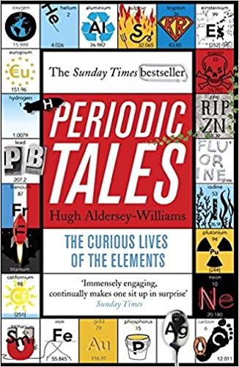
Periodic Tales: The Curious Lives of the Elements (Paperback) Hugh Aldersey-Williams
ISBN-10: 0141041455
This book covers the chemical elements, where they come from and how they are used. There are loads of fascinating insights into uses for chemicals you would have never even thought about.
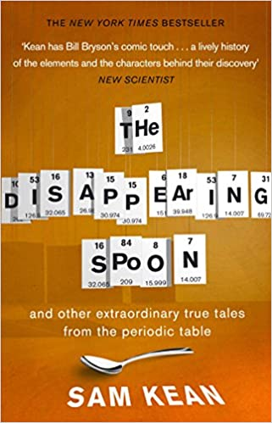
The Disappearing Spoon (Paperback) Sam Kean
ISBN-10: 0552777501
This is another book that contains amusing and informative tales about how many of the elements were discovered and the stories behind them and how many of the elements helped shape the course of human history itself.

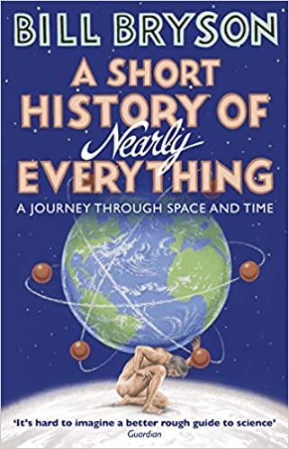
A Short History of Nearly Everything (Paperback) Bill Bryson
ISBN-10: 9781784161859
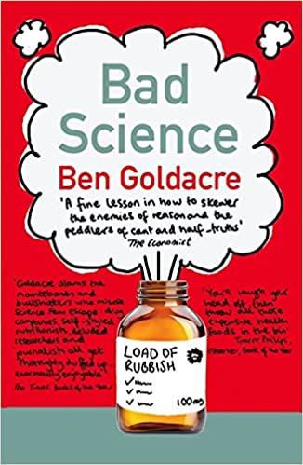
This book covers the history of science itself and the stories of many of the greatest scientific discoveries of all time. It is written by a non-scientist, so it is great at explaining many scientific theories in ways that any layperson can understand. It tells the stories of the greatest heroes and villains across the history of science and will help you put a face to many of the scientists we mention throughout any of the three science courses. The audiobook version is also great!
Bad Science (Paperback) Ben Goldacre
ISBN-10: 000728487X
Here Ben Goldacre takes apart anyone who published bad / misleading or dodgy science. This book will make you think about everything the advertising industry tries to sell you by making it sound ‘sciency’. But it will also give a good idea of the importance of a robust scientific method.

Magazines such as New Scientist or Scientific American are also excellent ways to read about the exciting new advances across all fields of science and maybe even to give you ideas about a future career in science!

Recommended Videos

Crash Course Chemistry – CrashCourse
This playlist offers a crash course in most of the topics we cover during the course. The videos often contain some of the history behind the science, as well as great animations and demonstrations of many of the concepts discussed.
https://www.youtube.com/playlist?list=PL8dPuuaLjXtPHzzYuWy6fYEaX9mQQ8oGr
Investigating the Periodic Table with Experiments - with Peter Wothers
Royal Institution lectures are always excellent and this one celebrates 150 years of the periodic table with lots of interesting facts and brilliant demonstrations.
https://www.youtube.com/watch?v=kqe9tEcZkno
A thread of quicksilver –The Open University
A brilliant history of the most mysterious of elements –mercury. This program shows you how a single substance led to empires and war, as well as showing you come of the cooler properties of mercury. (This video is a little old, so the quality isn’t great)
https://www.youtube.com/watch?v=t46lvTxHHTA
10 weird and wonderful chemical reactions
10 good demonstration reactions, can you work out the chemistry of .... any... of them?
https://www.youtube.com/watch?v=0Bt6RPP2ANI

Preparation for A-Level Chemistry

In order to make the transition from GCSE to A-Level Chemistry as smooth as possible. It is important to have a solid grasp of many fundamental concepts that you learnt as part of your GCSE course.
The following section contains several activities that aim to consolidate these skills and improve any content you may be a bit rusty on. Once you have completed these tasks, you can check the answers using the answer section in this booklet. You will then be ready to have a go at the “WKGS AS Chemistry Summer Work” booklet. This will be collected in and marked when you start the course in September.
Resources that will help you complete these activities include:
- http://www.bbc.co.uk/schools/gcsebitesize/
- http://www.s-cool.co.uk/gcse
- Any GCSE Additional Science / Chemistry revision guide
- Your own old GCSE Science / Chemistry folders or exercise books
- Head Start to AS Chemistry Published by CGP (although this is not essential!)

Some tasks have space for you to write your answers, but you will need to answer some sections on a separate piece of paper.

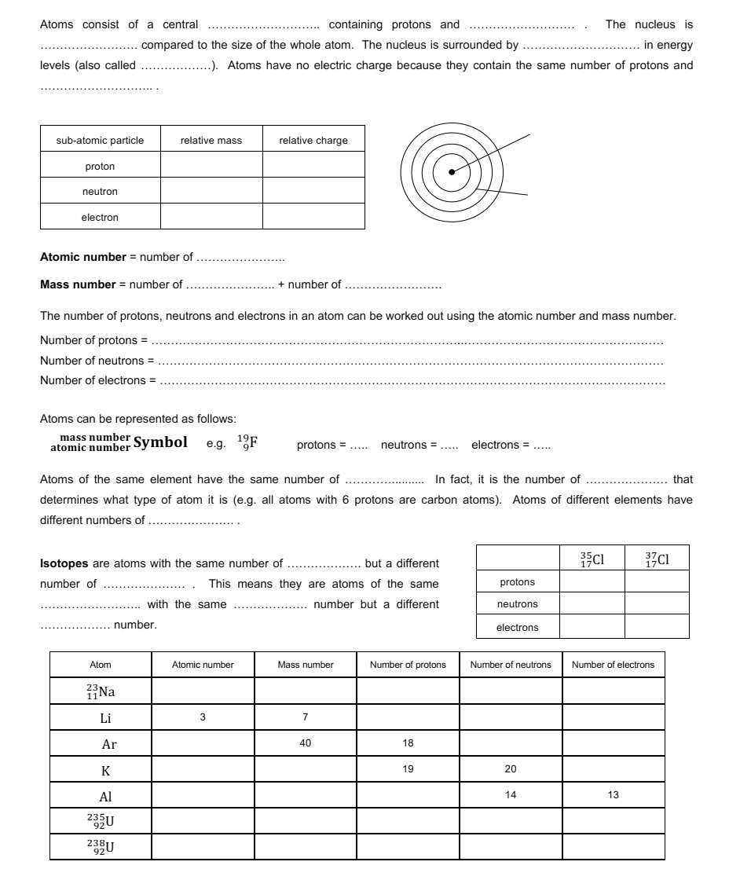
Task 1 – Atomic Structure

Task 2 – Writing Chemical Formulae
Being able to confidently write the correct chemical formulae for a substance is probably the single most important skill for any student that wants to succeed at A-Level chemistry.
If you are at all unsure on how to do this I highly recommend reading the guide in this link - https://www.my-gcsescience.com/tips-writing-chemical-formulae/
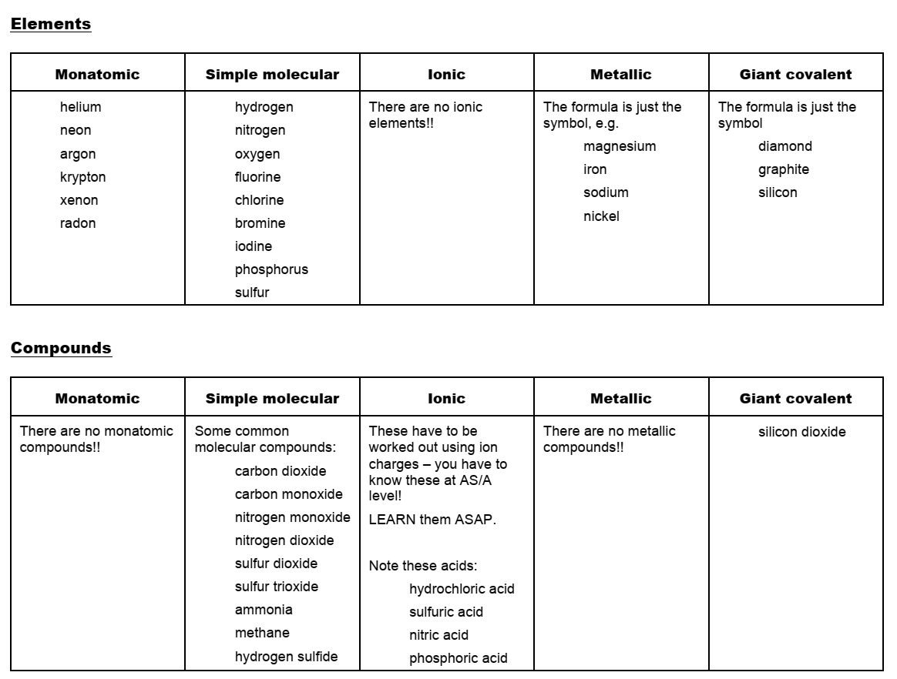
You should be able to use the information in the table below and the link above to correctly give chemical formulae for any substance you are asked.

Remember, you will not be able to use the periodic table to work out every ion. For example, transition metals do not have a group number, but they will have a number after them in roman numerals which is equal to their charge. Also, some complex or polyatomic ions you will just have to learn. You will be expected to know the ions listed below (and more) at A-Level.
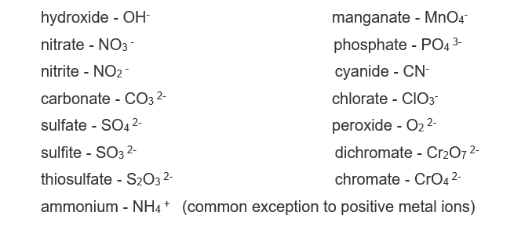

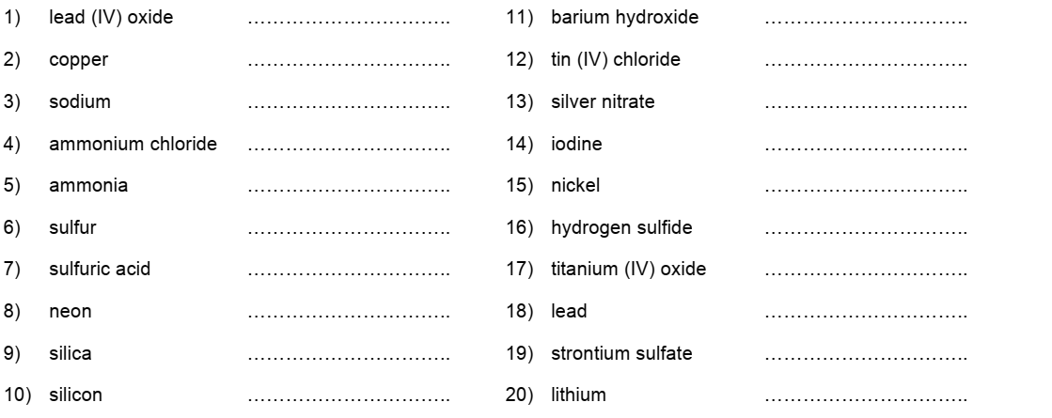
Write the chemical formulae for the following compounds:

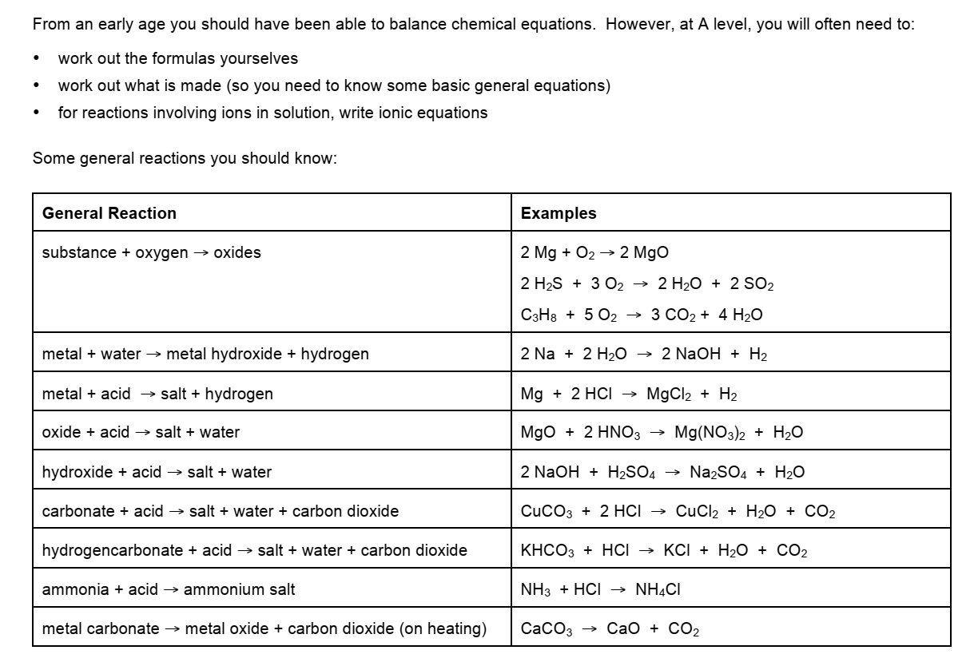
Task 3 – Chemical Equations

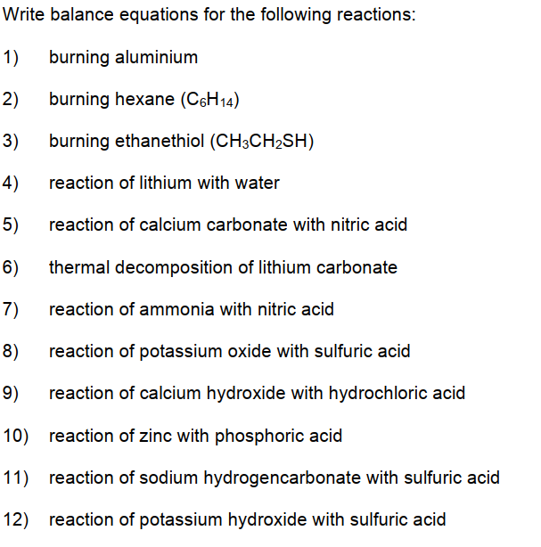

Task 4 – Ionic Equations
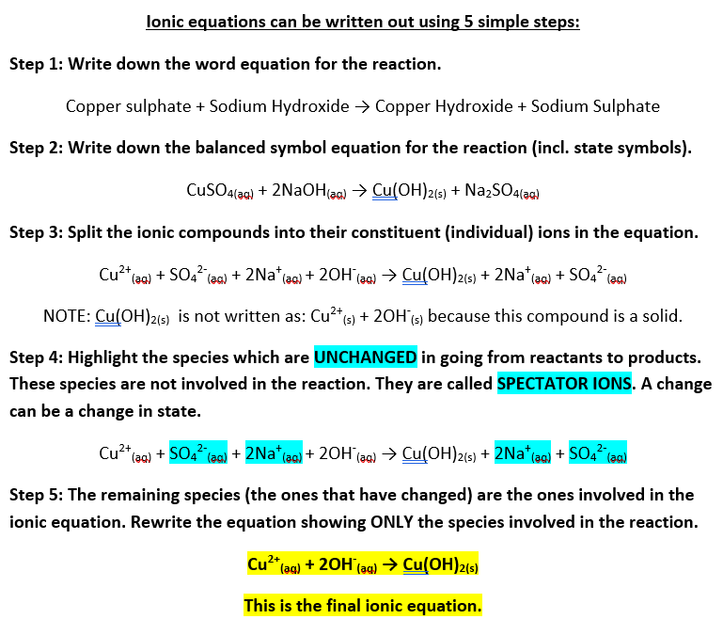
A balanced ionic equation shows the reacting ions in a chemical reaction. These equations are used to represent what happens in precipitation reactions (reactions in which an insoluble solid is produced during a reaction in solution).

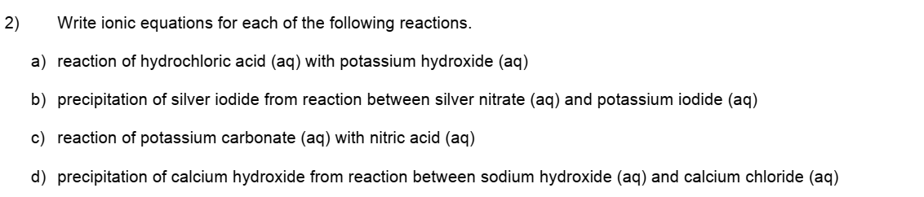
HINT: Look at the general reactions you should know on page 16 if you are struggling with a & c

Task 5 – Amount of Substance Calculations
At GCSE you will have studied various calculations to determine amounts of substance. This could have been the number of moles of a gas you have, the mass of a solid that will be produced from a reaction, the % yield or atom economy of a reaction. All these skills transfer directly over to the A-Level course. The more comfortable and confident you can be using these types of calculations, the easier you will find the transition to A-Level Chemistry.
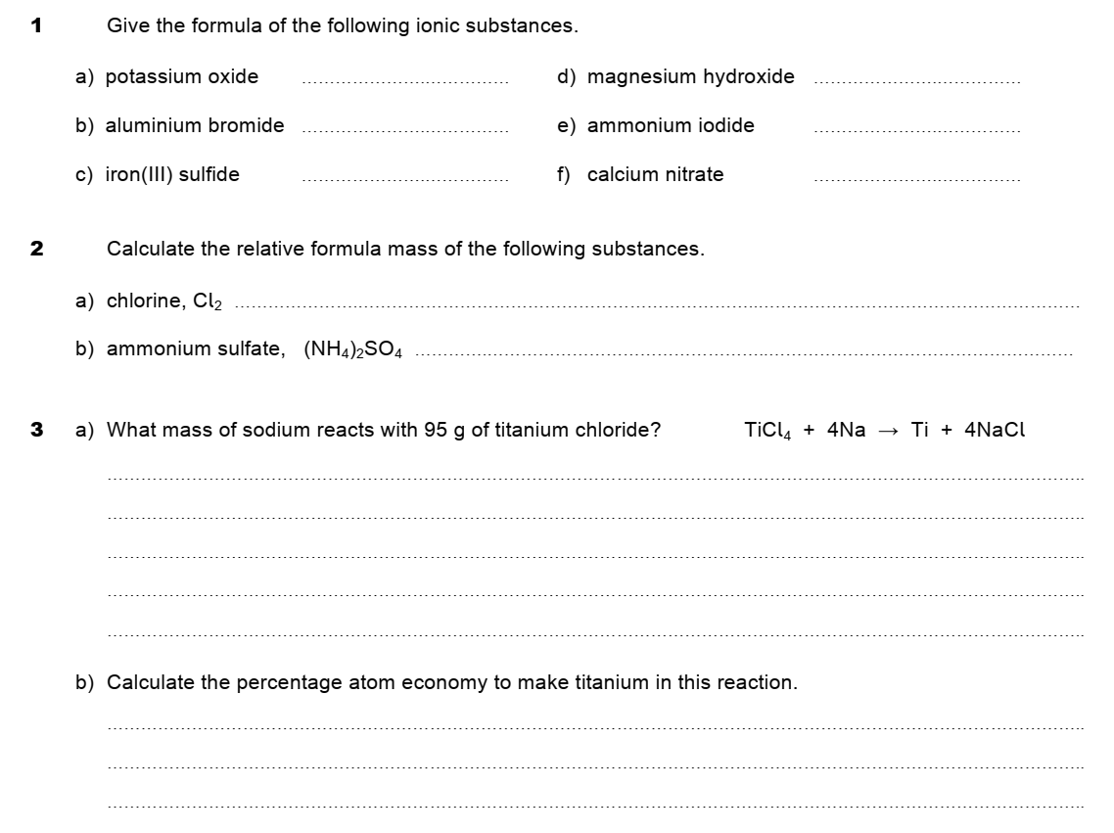
I highly recommend you dig out your old Chemistry notes or revision guide and have a go at the following questions. Practice makes perfect!
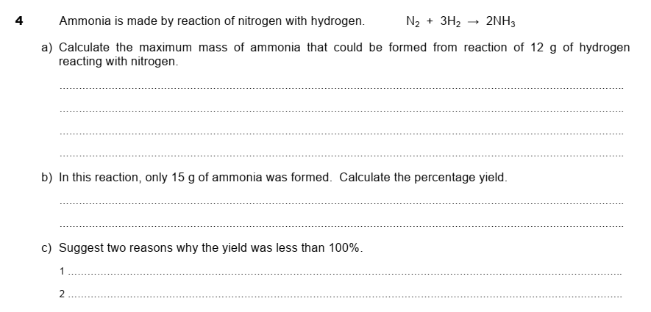

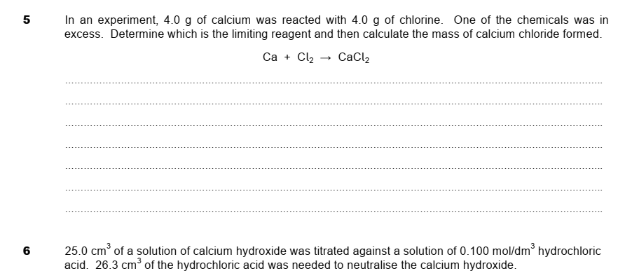
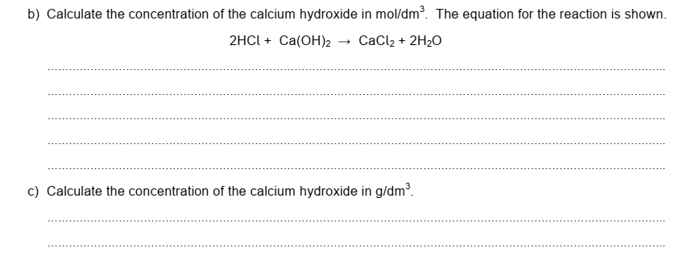

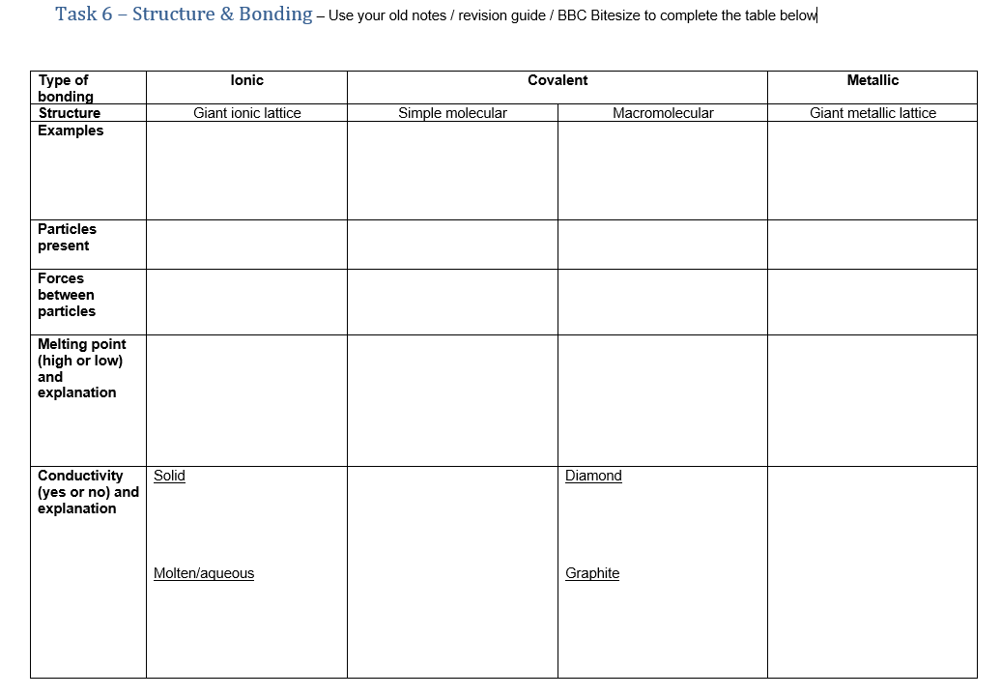

Task 7 – Organic Chemistry
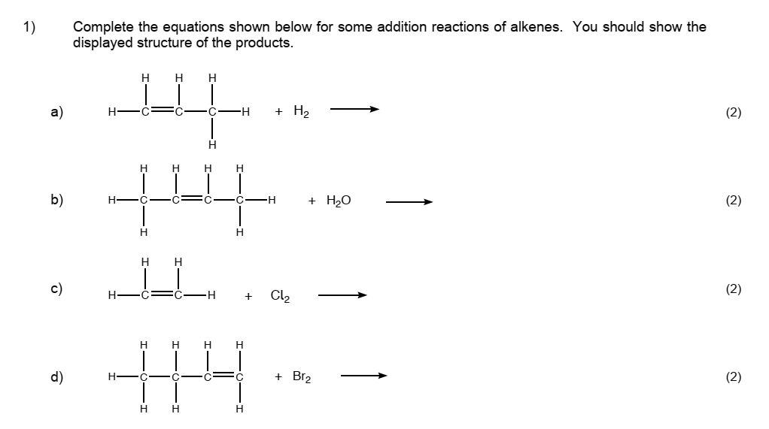
Organic Chemistry is one of the most important areas of all Chemistry. Many of the materials, fuels and medicines we use on a regular basis are based on Organic Chemistry and it makes up a significant portion of the A-Level Chemistry course. For this reason, it is important you are familiar with the basics. Use your old notes / revision guide / BBC Bitesize to help you answer the questions below.

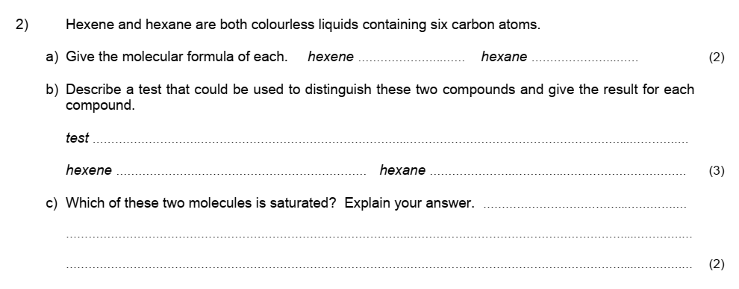

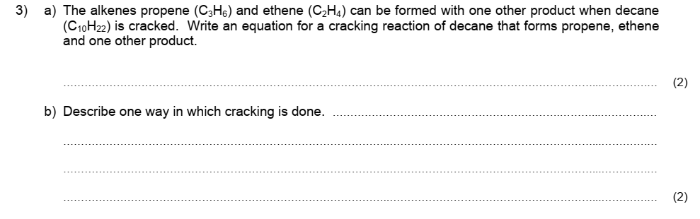

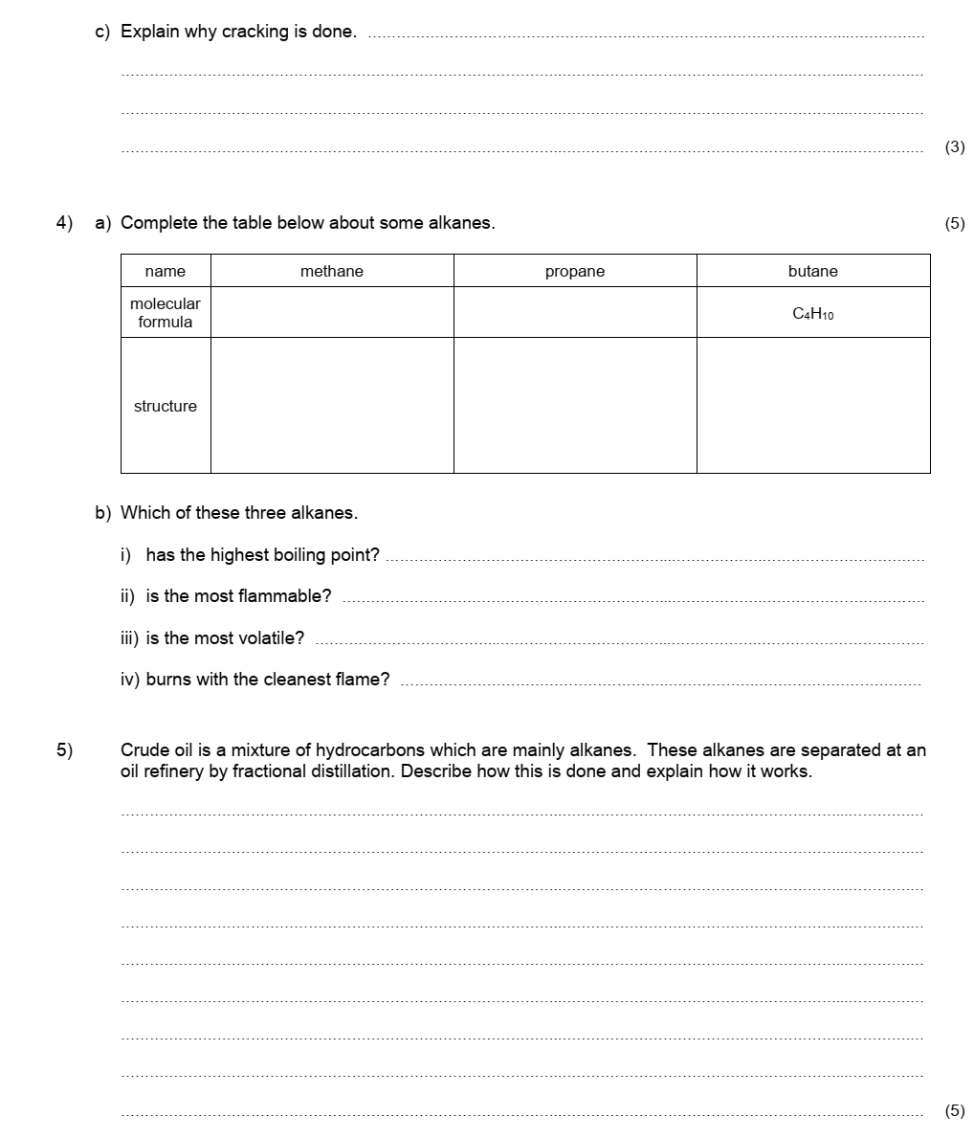

Now you have completed all of the tasks, you should be ready to have a go at the “WKGS AS Chemistry Summer Work” booklet. As mentioned previously, this will be collected in by your teacher during the first few weeks of the new term in September.

Task 1 – Answers
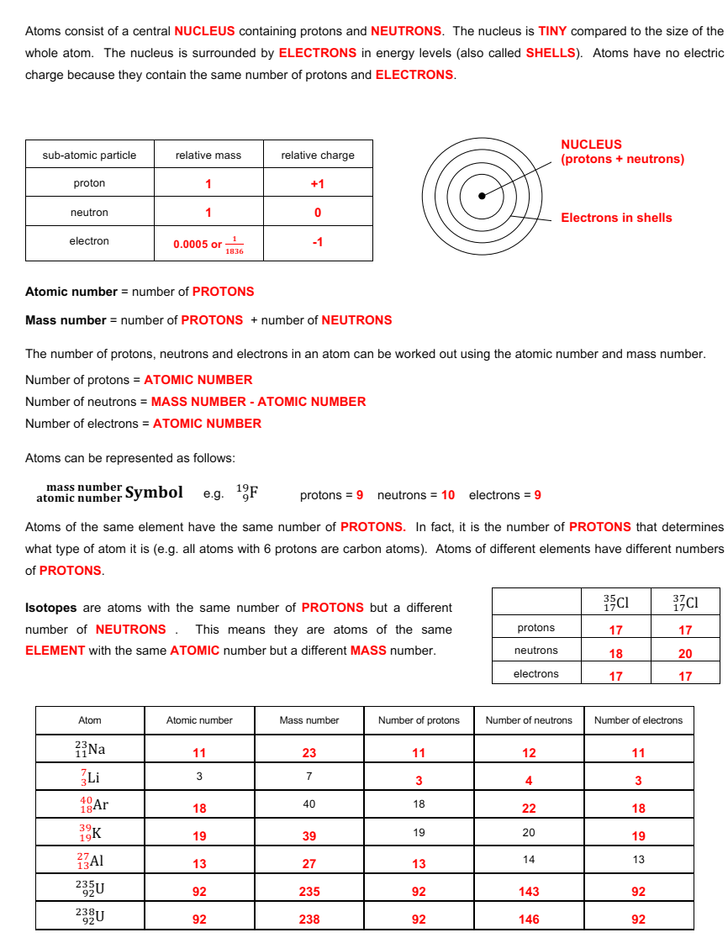

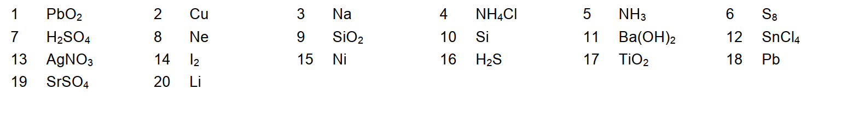
Task 2 - Answers

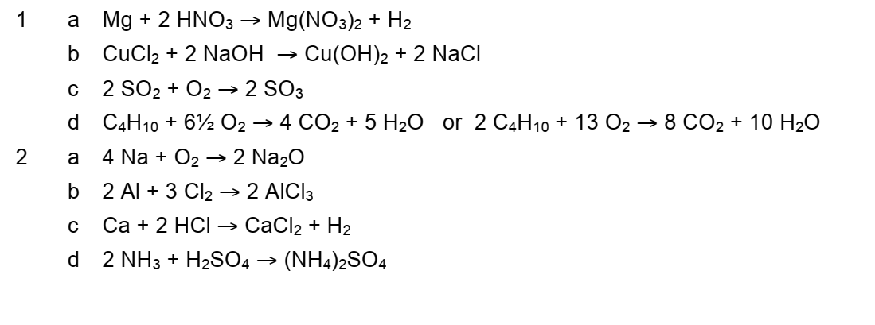
Task 3 – Answers

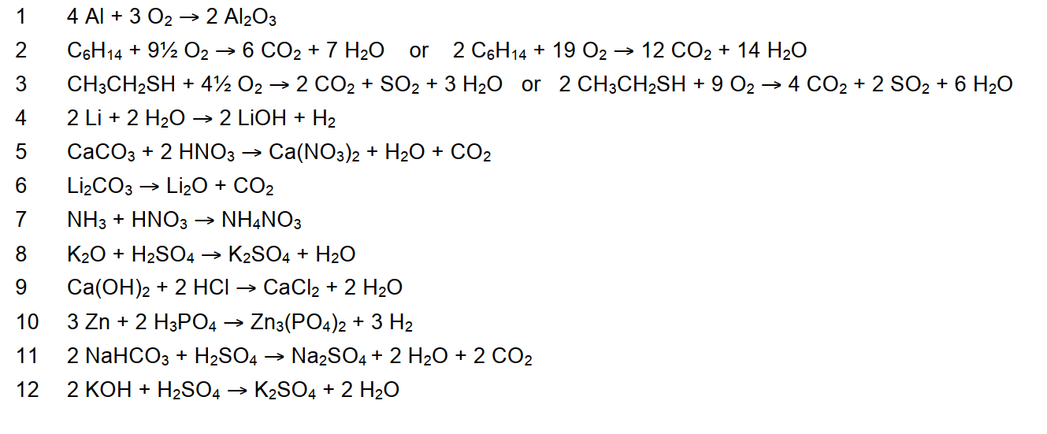

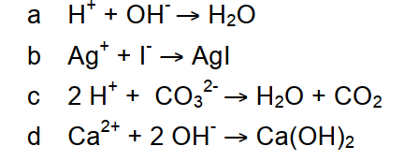
Task 4 - Answers

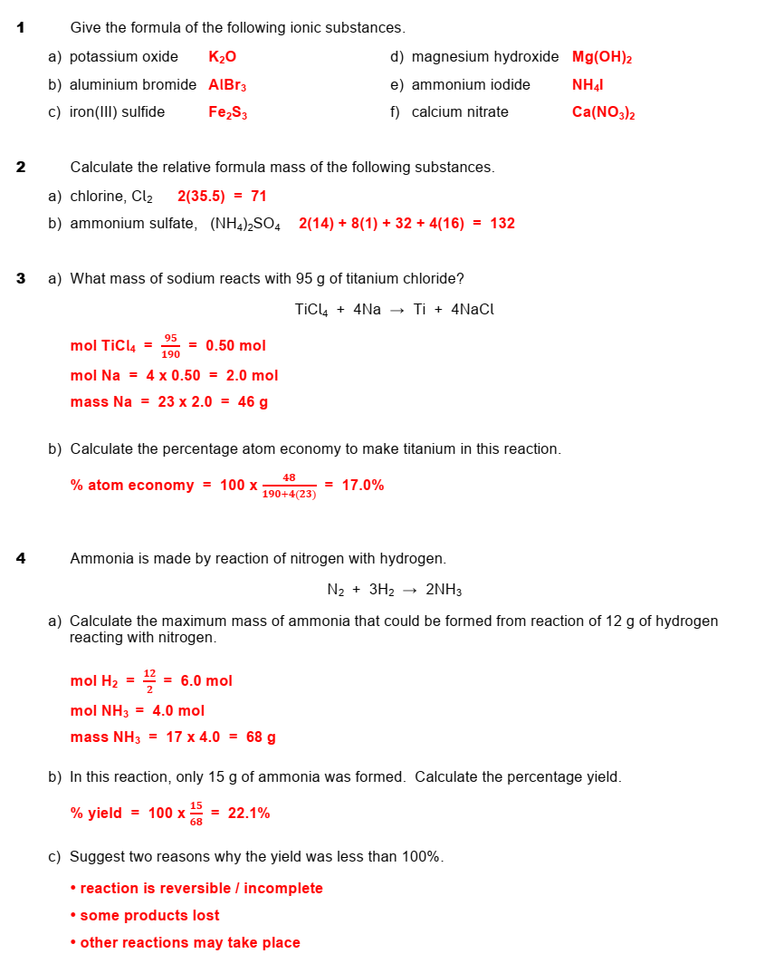
Task 5 - Answers
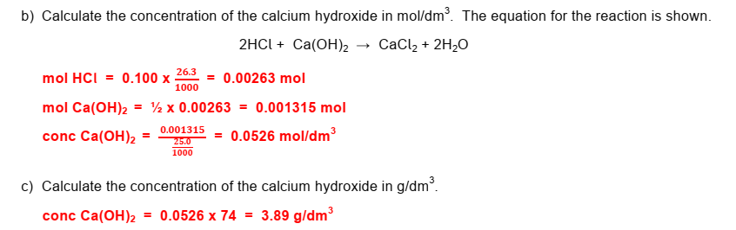
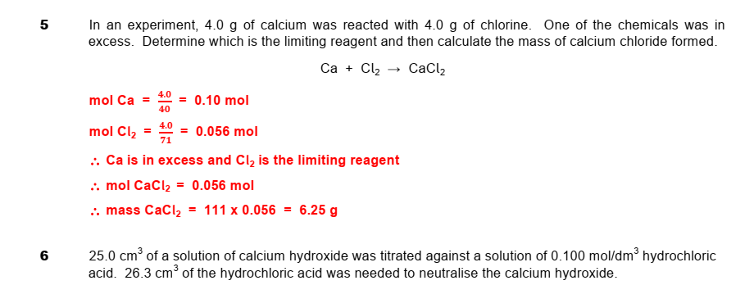

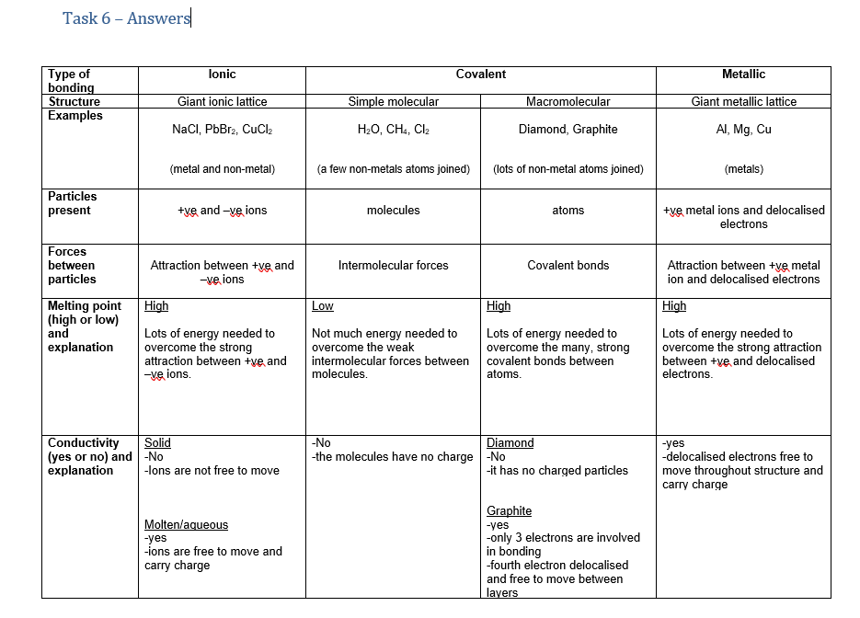

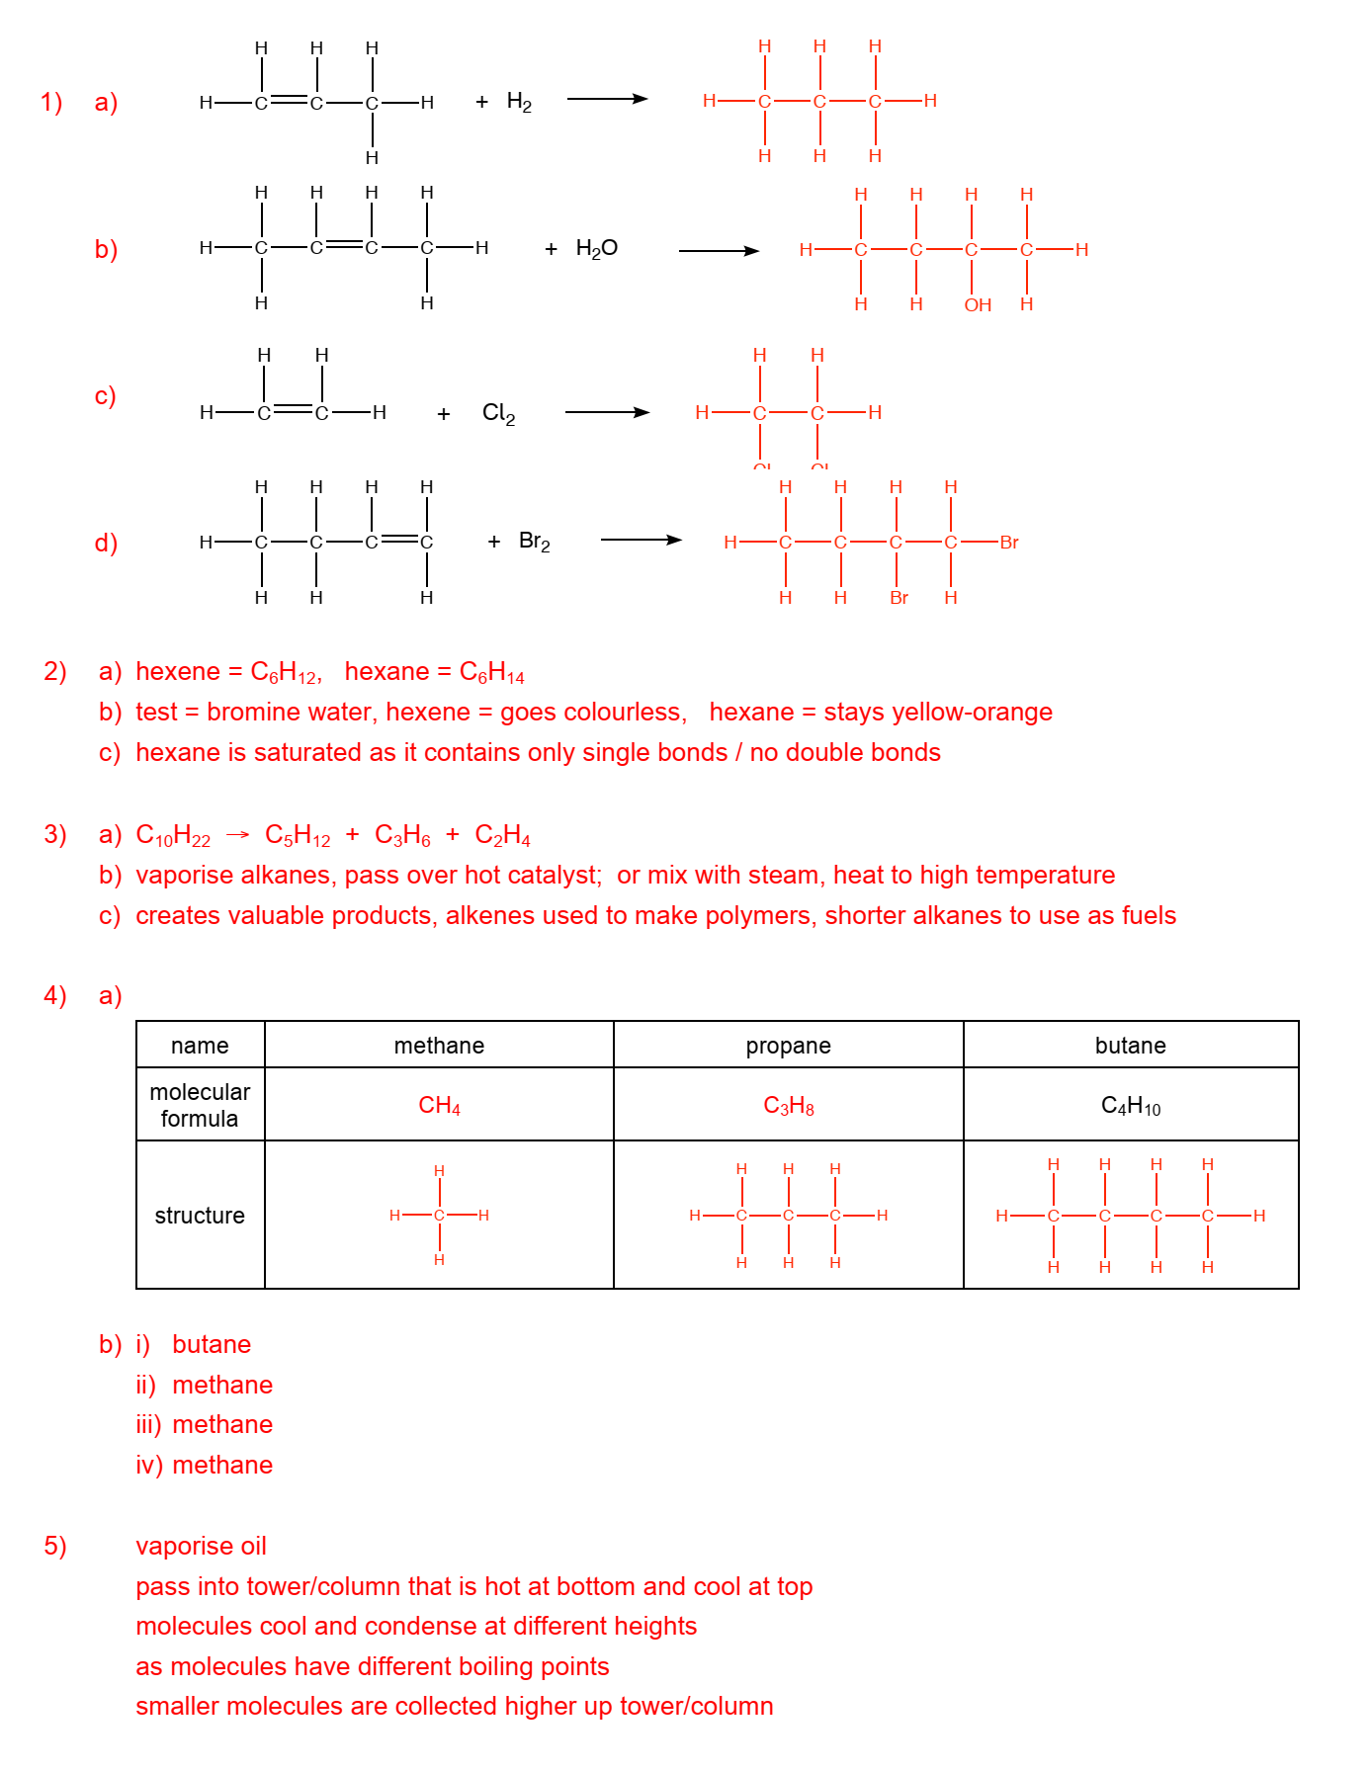
Task 7 – Answers

