A-LEVEL PHYSICAL EDUCATION – SUMMER WORK 2023
KEY QUESTION – SHOULD ATHLETES USE ERGOGENIC AIDS/PERFORMING ENHANCING DRUGS/ILLEGAL PROCEDURES?

INTRODUCTION
The desire to win at all costs in the competitive world of modern sport means that performers continue to take drugs/various ergogenic aids illegally, despite the obvious risks and consequences. You require an understanding of the reasons why sports performers take drugs, possible arguments for their legalisation and ways in which drug taking can be eliminated. As well as the physiological performance benefits and risks associated with taking illegal drugs/methods.

Task 1: Read the article ‘Doping offences that shocked the world’ AND’ the fight against doping’. See appendix (end of this document)
Task 2: Write your own article concerning the ethics around doping in sport. Explain why some athletes take performance enhancing drugs (e.g. anabolic steroids etc) or participate in illegal methods (e.g. blood doping), despite the risks/consequences.
Include detail on the physiological, social, psychological benefits.
Discuss the consequences and implications to the performers themselves, the sport they are involved in and the impact on society.
Highlight any strategies that are employed to stop the use of illegal drugs and doping.
Should we support a ban? Should we support legalisation?
Conclusion

Task 3: Watch the following Clips
Skeleton, Joints, Muscles, Movements A-Level PE - YouTube
CIE IGCSE PE - Muscle Fibre Types - YouTube

Complete Task 4 and 5

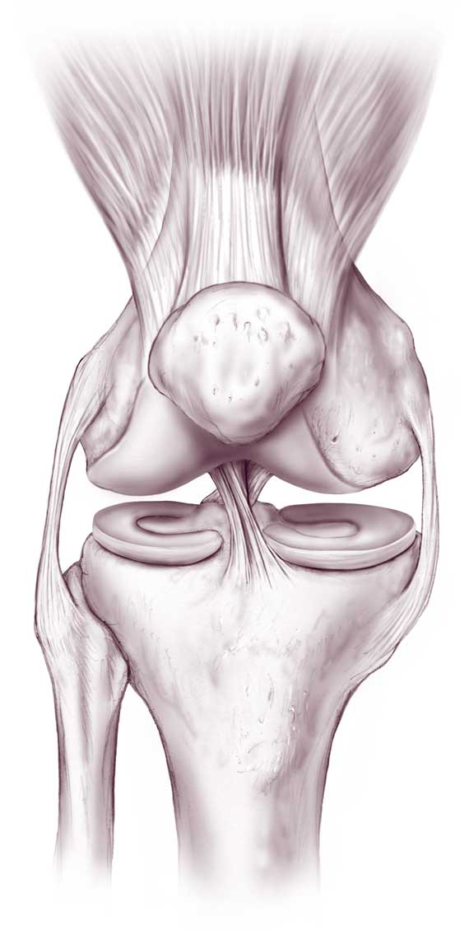
WELCOME TO A-LEVEL P.E. (Anatomy & Physiology)
TASK 4
As part of the Applied anatomy and physiology work, you are required to gain a detailed understanding of the skeletal and muscular systems.
On an A3 piece of paper design a factual poster of two major joints in the body. You should choose a joint from the upper body (shoulder, elbow or wrist) and a joint from the lower body (hip, knee or ankle).
Your poster, must include:
- An anatomical diagram of each joint.
- What type of joint it is ( e.g. hinge etc). Wrist is a condyloid joint!
- The bones that articulate at the joint.
- The muscles that are involved at the joint.
- The movements that can take place at the joint (e.g. flexion etc).
- Explanation of the function of the components of a synovial joints (to include – ligaments, tendons, cartilage, synovial fluid, bursa and joint capsule).
- Give detailed practical examples of when the joint is used during sporting actions.

You can present your poster in any way that you would like. Make sure that your information is correct. You can include diagrams.
You will then be required to present this information during a lesson. Go to the OCR A-Level PE website. Then click on planning and teaching resources. There is also a very useful power point on the skeletal and muscular systems that would will help you. You will find it in the Topic exploration packs.

All of your work will be marked

TASK 5

One part of applying the theory to a sporting performance, requires you to produce a movement analysis.
- For ONE skill from your main sport (e.g. shooting technique in netball, tennis serve technique or track start off the blocks in swimming etc), you need to identify the movement phases of one upper body joint and one lower body joint. What you need to do? To identify …

- The movements that have taken place at the 2 joints at different stages of the performance of the skill you are looking at e.g. flexion in the preparation phase. There are some new movements that you haven’t come across before that you will need to research (they are horizontal flexion and extension at the shoulder, dorsi-flexion and plantar flexion at the ankle, medial and lateral rotation at the shoulder and hip joints)!!

- The agonist muscle.

- The antagonist muscle.

- The joint type e.g. ball & socket.

- The bones that articulate at the joint.

- The type of muscle contraction taking place (concentric, eccentric or isometric).

REMEMBER that more than one movement pattern may take place at each joint.

Use the tables to help you

SKILL__________________________________________
IMAGE OF PREPARATION PHASE

IMAGE OF EXECUTION PHASE

IMAGE OF RECOVERY PHASE

 | JOINT TYPE | BONES AT JOINT | MOVEMENT | AGONIST | ANTAGONIST | TYPE OF CONTRACTION/PLANE OF MOVEMENT
Upper body Joint

Lower body joint

SKILL _____________________________ PHASE____________________________

 | JOINT TYPE | BONES AT JOINT | MOVEMENT | AGONIST | ANTAGONIST | TYPE OF CONTRACTION/PLANE OF MOVEMENT
Upper body Joint

Lower body joint

SKILL _____________________________ PHASE____________________________

SKILL _____________________________ PHASE____________________________

 | JOINT TYPE | BONES AT JOINT | MOVEMENT | AGONIST | ANTAGONIST | TYPE OF CONTRACTION/PLANE OF MOVEMENT
Upper body Joint

Lower body joint

MOVEMENT ANALYSIS HELP TABLE
JOINT | JOINT MOVEMENT | AGONIST MUSCLE  (Concentric Muscle Contraction) | ANTAGONIST MUSCLE  (Eccentric Muscle Contraction)
WRIST | FLEXION | WRIST FLEXORS | WRIST EXTENSORS
 | EXTENSION | WRIST EXTENSORS | WRIST FLEXORS
ELBOW | FLEXION | BICEPS BRACHII | TRICEPS BRACHII
 | EXTENSION | TRICEPS BRACHII | BICEPS BRACHII
SHOULDER | FLEXION | ANTERIOR DELTOID | POSTERIOR DELTOID
 | EXTENSION | POSTERIOR DELTOID | ANTERIOR DELTOID
 | HORIZONTAL FLEXION | PECTORALIS MAJOR | POSTERIOR DELTOID/TERES MINOR
 | HORIZONAL EXTENSION | POSTERIOR DELTOID/TERES MINOR | PECTORALIS MAJOR
 | ABDUCTION | MIDDLE DELTOID | LATISSIMUS DORSI
 | ADDUCTION | LATISSIMUS DORSI | MIDDLE DELTOID
 | MEDIAL ROTATION | SUBSCAPULARIS & TERES MAJOR | INFRASPINATUS & TERES MINOR
 | LATERAL ROTATION | INFRASPINATUS & TERES MINOR | SUBSCAPULARIS & TERES MAJOR
