Students who have chosen A Level English Language
Dear Student,
It’s great you’ve expressed an interest in studying English Language at A Level.
Part of studying English Language at A Level is thinking how you have been manipulated through language to feel a certain way about something.
We’d like you to start the course as independent minded learners and so we’re encouraging you to do some media reading over the summer.

We would like you to choose a well-known person who is written about in the media. This could be an actor, politician, famous scientist, musician, sportsperson or anyone else with a media profile. If they are a slightly (or very) controversial person, so much the better. For instance, Meghan Markle was a not particularly well known American actor until she got engaged to a certain Prince. Suddenly, Meghan Markle is getting millions of searches on Google and a great many opinions articles and reports written about her.

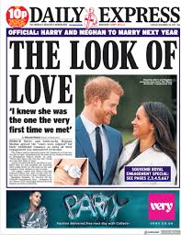
Find an article in the media about this person (this could be from a newspaper, magazine or website), and look particularly for one where the writer seems to be portraying a certain image of this person; perhaps they are making you feel sympathetic towards them or maybe they are trying to turn your opinion against this person - it could be quite subtle!

Produce a short powerpoint presentation in which you do the following:

- Show us some extracts from the text (you do not have to write about the whole thing – select the best bits).
- Give a short overview of how the person is being portrayed or represented.
- Select some key words, phrases or ideas which you feel particularly help to create this representation and briefly explain your choices.

When you come back in September, we will be asking you to present your work to the class.

Representation is a key topic of the A-level and this will give you a head start.

Good luck!

The English Department.

