Psychology
Summer preparation work for A Level 2021/2023

Staff
Mrs L Hughes (Head of Department)
Miss S Cliffe
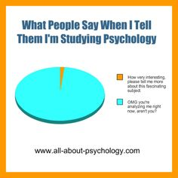
Welcome to Psychology!
Well done! You have chosen to study a fascinating scientific subject. Psychology is the science of behaviour and experience and you will learn how to apply what you study over the next two years to explaining numerous aspects of human behaviour.
This is a subject new to all students in the sixth form therefore the work suggested in this preparation booklet is designed to introduce you to some of the classic theorists that you will study. There will be lots of new terminology to grasp and it would be useful for you to familiarise yourself with some of this. These unfamiliar and somewhat challenging words may scare you, but you might well impress others with your notable language skills!
So, by completing this booklet together with the subsequent study of Psychology, you will:
- learn about research studies conducted by psychologists
- learn about their theories
- learn great words to use to impress others!
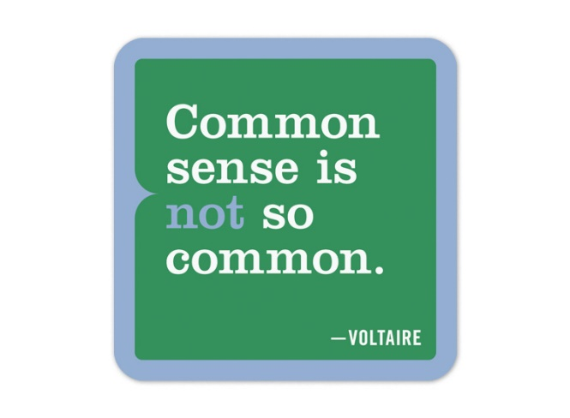
Some people think that Psychology is just common sense – but it isn’t. In some ways, psychology can be seen as a test of common sense. Psychology has shown that what we have always strongly believed to be true often turns out to be wrong, and sometimes things that sound like wild ideas turn out to be supported by scientific research. Psychology specialises in what are called counter-intuitive findings. These are the results from psychological research studies
that you didn’t expect, and which pleasingly and surprisingly contradict common sense. You read them, and you think, ‘well, how about that then?’
Your task is to do some research into a number of classic studies in Psychology that you will study in your first year. Using the library or web-based sources (see suggested list on page 4) read up and summarise the following classic studies.
Please set out your research for each study in the following format - APFCC
Aim – What were the researchers hoping to find? - one or two sentences is fine
Procedures – How did they carry out the study? – this is best set out as a series of bullet points outlining step by step what the researchers actually did
Findings – What were the results of the study? – can you summarise the findings in a table of results or a couple of sentences?
Conclusions – What could these results mean? – try and explain what these results suggest rather than just re-stating the findings- again a couple of sentences is sufficient here
Criticisms – Identify strengths & weaknesses of the study – can you summarise in a brief paragraph what was good and/or bad about how the study was carried out? Were there any ethical issues?(If you don’t know what ethical issues are – research & find out!)
CLASSIC STUDIES
Social psychology – Social Influence Cognitive psychology - Memory
Milgram (1963) – obedience to authority figures | Shallice & Warrington (1970) – case study of KF

Developmental psychology – Attachment Approaches
Lorenz (1935) – imprinting in ducks & geese | Pavlov (1902) – classical conditioning in dogs
Harlow (1959) – social isolation experiments on rhesus monkeys | Skinner (1953) – operant conditioning with rats in the ‘Skinner box’
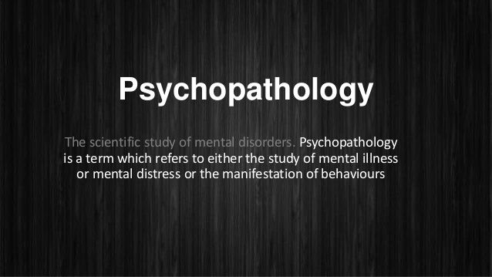
Then, next topic …….
Psychopathology .
Research and list characteristics (symptoms) for the following disorders
Depression (unipolar)
OCD
Phobia (a specific phobia e.g. a phobias of dogs)

Important points to note when researching information.
- Do not cut and paste information from websites – this is plagiarism and will not aid your learning
- Read through the information a few times and then try and put it into your own words. This will help you to retain the important information.
- Don’t write down anything that you do not understand. Make a separate note of what you are unclear of and we will go over this in September.
- Think about what you are writing. Include your own criticisms, comments and questions in your notes.
- Do not use Wikipedia.
Some recommended websites - You can develop your interest in the subject by accessing up to date newsworthy topics on the following

www.bps.org.uk – official web site of the British Psychological Society. Information on education, careers, student membership, current research etc.
www.researchdigest.org.uk – blog on cutting edge reports on the latest psychological research.
www.scholar.google.co.uk
www.ted.com
www.thepsychologist.org.uk
www.thinkneuroscience.wordpress.com
www.medicalnewstoday.com
www.guardian.co.uk/education
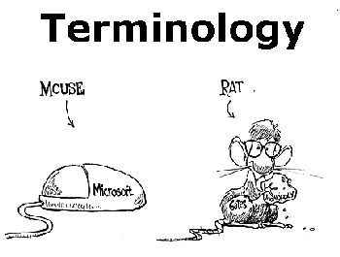
New subject……
..new language

Find out what the following terms mean – try and use your own words!
Agoraphobia | Empiricism | Placebo
Androcentrism | Fight or flight response | Quantitative data
BPS (hint – second word is ‘psychological’) | Flooding therapy | Qualitative data
Cognitive behavioural therapy | Meta-analysis | Reductionism
Determinism | Measures of central tendency | Schema
Dopamine | Norms | Variables
DSM-5 | Pilot study | Zero correlation

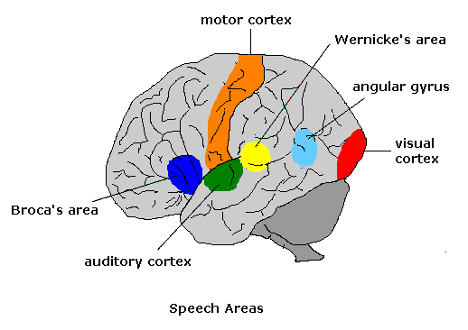
Phew!

That might all seem like hard work so there are also some films you could watch that have strong psychological themes throughout. (WARNING – some of these are certificated 18 – so check with parent/carer that it is ok for you to view them)

You might also want to look up some intriguing individuals in Psychology….
See what you can find out about…….
Cyril Burt
Phineas Gage
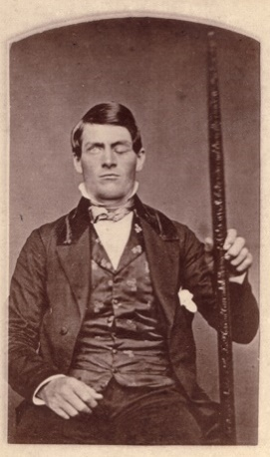
Genie (feral child)

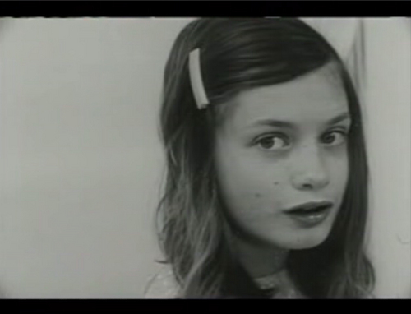
So………can the study of Psychology really help us to control behaviour?
A real life explanation…..
Managers at Schiphol Airport in Amsterdam wanted to know how you might stop men from missing the urinals and making a mess on the floor of the airport toilets. They could put up signs telling them to be more careful, or warning them of dire consequences if they don’t get their aim straightened out.
But here’s a better idea. Initial research highlighted that apparently (!) men like nothing more than having something to aim at. So men’s urinals at Schiphol Airport were given a small but significant redesign. A tiny black spot, in the shape of a fly, was inlaid into the middle of the pristine white porcelain urinal. It stood out like …..well, like a fly on a white urinal.
Although no truly scientific studies have been conducted into the effectiveness of the method, apparently Schiphol’s cleaning costs were reduced by 8%!

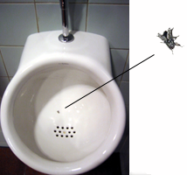

Please bring this booklet and the work you have completed over the summer with you to your first Psychology lesson.
See you in September!

