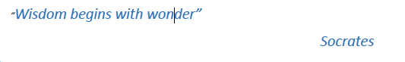
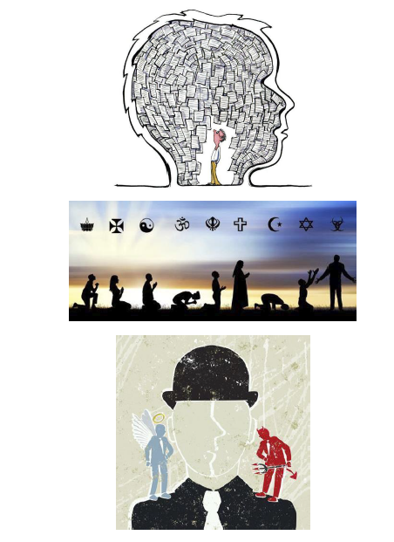
A Level Philosophy, Religion and Ethics
Year 11 into 12 progression booklet.
Philosophy Task

Watch this debate between William Lane Craig and Christopher Hitchens.
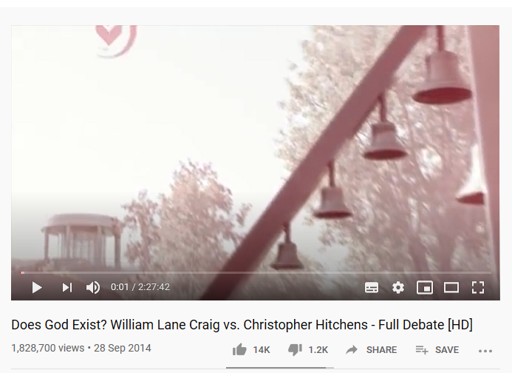
https://www.youtube.com/watch?v=0tYm41hb48o
The video is called
Does God Exist? William Lane Craig vs. Christopher Hitchens - Full Debate [HD]
If you watch from 11 minutes 30 seconds you will see William Lane Craig and Christopher Hitchens being introduced. William Lane Craig is a Christian and Christopher Hitchens was a New Atheist.

Structure of the talk
The lecture is quite long and so you may wish to watch this in stages. They talk for 20 minutes each and then have a right of reply each.

- William Lane Craig starts at 13 minutes
- Christopher Hitchens starts at 33minutes and 30 seconds
- Williams Lane Craig replies to Christopher Hitchens from 54 minutes and 15 seconds
- Christopher Hitchens replies to William Lane Craig from 1hr and 7 minutes
From one hour 20 minutes there is a cross examination that you may wish to watch.

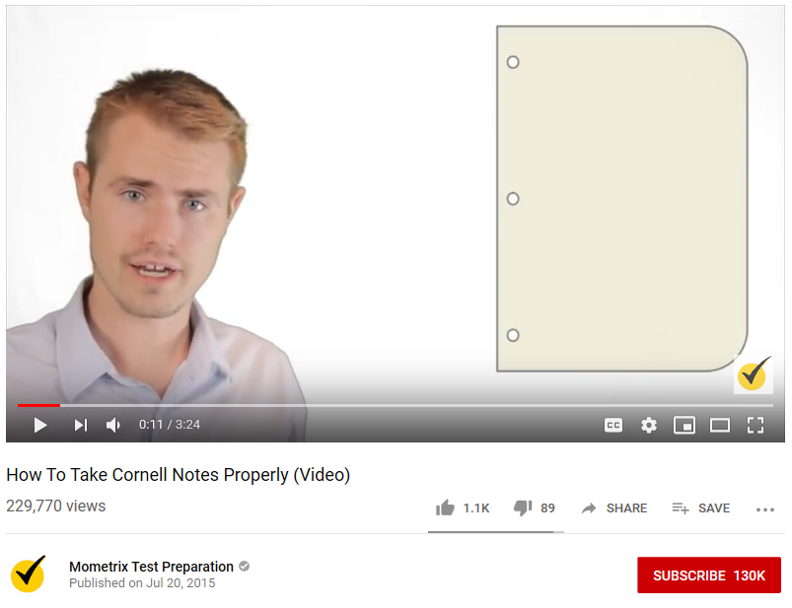
Having watched the videos you are going to complete a Cornell Notes activity. There are instructions on how to take Cornell Notes on the video below.
https://www.youtube.com/watch?v=ErSjc1PEGKE
The video is called:
How to take Cornell Notes properly

At the bottom of this information is an example of some completed Cornell Notes for you to see on a different topic.
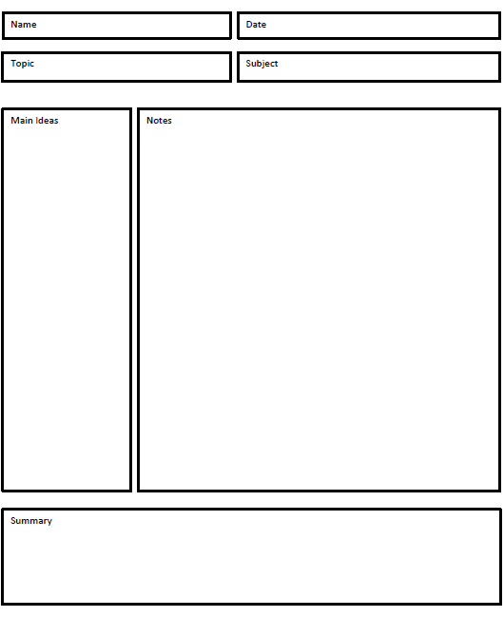
William Lane Craig’s arguments for God’s existence
Philosophy – Does God exist?

Christopher Hitchens’ case for God not existing
Philosophy – Does God exist?
Philosophy, Religion and Ethics Task

Who’s Who?

These are some of the key figures you will come across in the A level course.

Task 1
You obviously need to have an overview of the life of Christ so create the table below and fill it in with the relevant details. You do not need pages on each section, but have a brief overview.

Event | What took place | Belief | Celebration
Birth
Baptism
Transfiguration
Entry into Jerusalem
Last Supper
Arrest
Crucifixion
Resurrection
Post Resurrection appearances
Ascension
Pentecost

Task 2
St Paul is a huge figure in the Christian tradition. Devise a table to explain the following key areas:
- His Background
- The Stoning of Stephen
- Conversion
- Missionary journeys
- His letters to the churches (also known as Epistles)
- His importance for the Church

Scholars
Whilst you will never have to write about the scholars it would be helpful to have some background and put them in context.
Task
Find a picture of each scholar and create a timeline.
Use the table below to find out what their contribution has been to the fields of philosophy, ethics and religion.
It only needs to be brief (more than two sentences but not pages and pages) so do not cut and paste vast amounts from wikipedia!!! You will need to be able to refer to these scholars throughout the course.

Plato | 428/427 or 424/423 BC - 348/347 BC (age c. 80)
Aristotle | 384-322 BC (62)
Irenaeus | 130-202 (72)
Augustine | 354 – 430 (75)
St Anselm | 1033 -1109 (76)
Thomas Aquinas | 1225-1274 (49)
Martin Luther | 1483-1546 (62)
John Calvin | 1509-1564 (54)
David Hume | 1711-1776 (65)
Jeremy Bentham | 1748-1832 (84)
John Stuart Mill | 1806-1873 (66)
Sigmund Freud | 1856-1939 (83)
Carl Jung | 1875-1961 (85)
Joseph Fletcher | 1905-1991 (86)
Gustavo Gutierrez | b.1928 (91)
Sallie McFague | 1933-2019 (86)
Richard Dawkins | b. 1941 (79)
N.T Wright | b. 1948 (71)
Alister McGrath | b. 1953 (67)

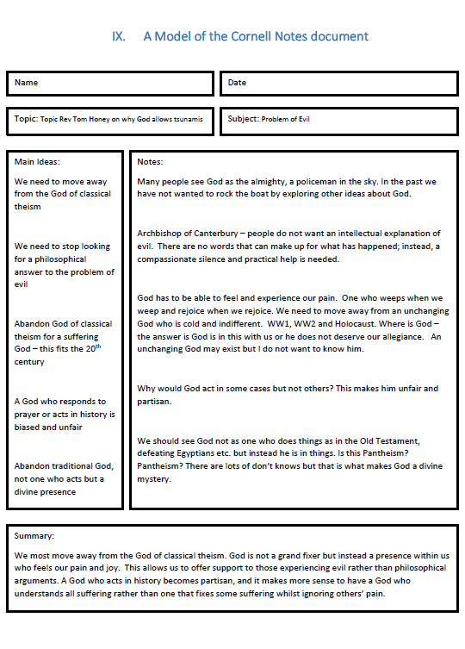

Context Task
It is important to be able to understand the context or setting which led to various movements in Philosophy, Religion and Ethics.
One of the most ground breaking eras was the 1960s as that led to a huge change in attitudes which had implications for Ethics (Situation ethics , attitudes to homosexuality contraception, abortion etc ) . As it also led to womens’ liberation it had an effect on feminist theology and also on liberation theology in South America.

It would be useful it you have an overview as to how important the 1960s were. Films and documentaries give you a good flavour, so watch anything that interests you.
There is a blank notes template below, which you can use to record your observations

Films and documentaries
The Sixties : series I episode 9 ‘The times they are a changin’
‘Made in Dagenham ‘ 15. About women trying to get equal pay
‘The Two Popes’ PG Benedict and Francis , but looks back to liberation theology in South America
The Imitation Game 12 About Alan Turing ( useful as background for application of Situation ethics)
The Story of God Morgan Freeman documentary

See else you can find.

