Dear Student,

It’s great you’ve expressed an interest in studying English Literature at A Level.

If you’re thinking of selecting this course, we’re hoping that you’re already an avid reader or would like to become one! With this in mind, we’d like you to have a go at reading the texts listed below over the summer.

Pre-2000 | Post-2000
A Room With a View – E.M. Forster | The Girls – Emma Cline

One reason we’ve asked you to read over the summer is, to get the most out of lessons, it would be beneficial if you had an understanding of key texts and where they fit in to what we study and how they may have influenced other writers. Another reason it that when we come to prepare for the coursework element of the A Level, you could use these texts as your choices.

If you don’t fancy either of these, use the Summer Reading List to give you some other ideas.

We look forward to hearing your views on the novels you have read in September.

The English Department.

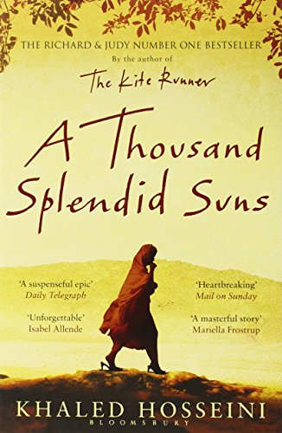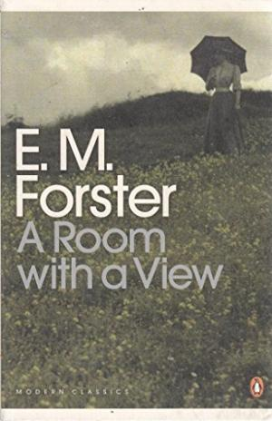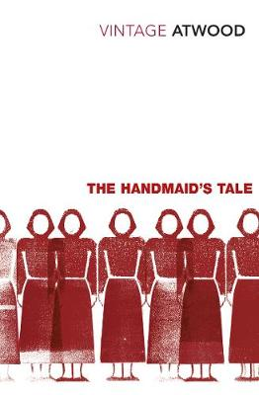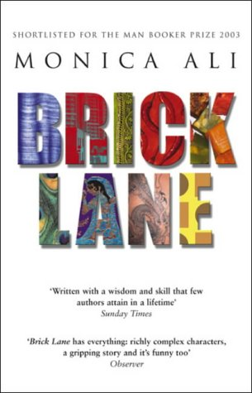

A Level English Literature Suggestions for Reading
Have a think about which types of books you’ve enjoyed in the past or which genre you tend to go for and see which from this list you’d like to read – maybe go for something different.
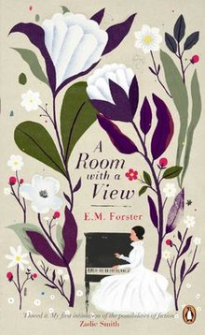
Pride and Prejudice – Jane Austen (1813)
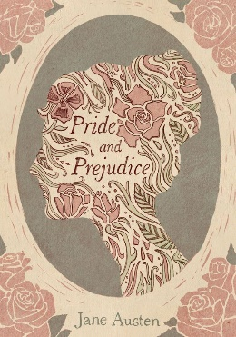
Jane Eyre – Charlotte Bronte (1847)
Wuthering Heights – Emily Bronte (1847)
The Scarlet Letter – Nathaniel Hawthorne (1850)
Great Expectations – Charles Dickens (1861)
Silas Marner – George Elliot (1861)
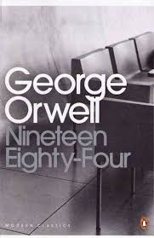
The Picture of Dorian Gray – Oscar Wilde (1890)
Tess of the D’Urbervilles - Thomas Hardy (1891)
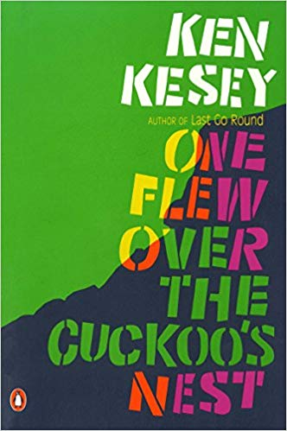
A Room With a View – E. M. Forster (1908)
The Age of Innocence – Edith Wharton (1920)
The Great Gatsby – F. Scott Fitzgerald (1925)
Brideshead Revisited – Evelyn Waugh (1945)
Nineteen Eighty-Four – George Orwell (1949)
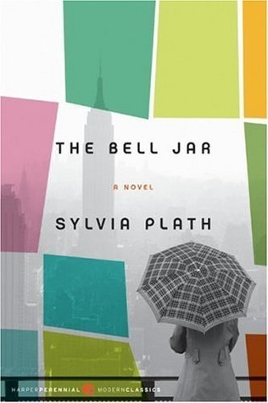
One Flew Over the Cuckoo’s Nest – Ken Kasey (1962)
The Bell Jar – Sylvia Plath (1963)
The Wide Sargasso Sea – Jean Rhys (1966)
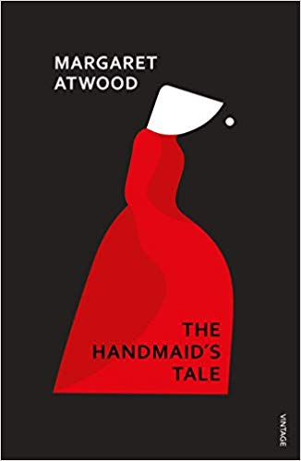
The Handmaid’s Tale – Margaret Atwood (1985)
Regeneration – Pat Barker (1991)
Birdsong – Sebastian Faulks (1993)
Enduring Love – Ian McEwan (1997)
Life of Pi by Yann Martel (2001)
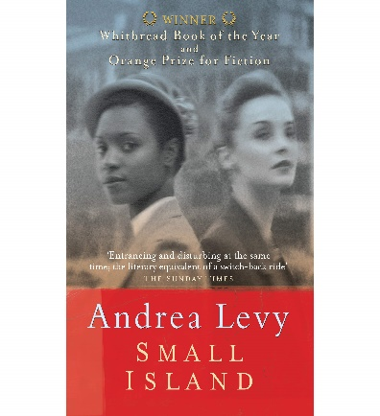
Brick Lane – Monica Ali (2003)
Small Island by Andrew Levy (2004)
Never Let Me Go – Kazuo Ishiguro (2005)
Thousand Splendid Suns – Khaled Hosseini (2007)
The Book Thief - Markus Zusak (2008)
Half of a Yellow Sun - Chimamanda Ngozi Adichie (2006)
Cloud Atlas - David Mitchell (2004)

