Geography A1 introduction: Changing Places – Liverpool
Read the GeoActive article 453 “Revitalising the CBD – Liverpool” (attached) and the website link about the “History of Liverpool” https://www.visitliverpool.com/things-to-do/maritime-and-heritage/history-of-liverpool then complete the following tasks:
- Look at the following news clip (3.30mins): https://youtu.be/GDhBK7KP4_0
Explain why the Toxteth riots of 1981 were the original catalyst for regeneration in Liverpool. (2 marks)
Write your answer here…
- Look at the photographs of the Albert Dock from 1910 and 1982:
2a. Describe the changes to the Albert Dock between the two photographs. (2 marks)
Write your answer here…
Now look at the photograph of the Albert Dock from 2010 below:
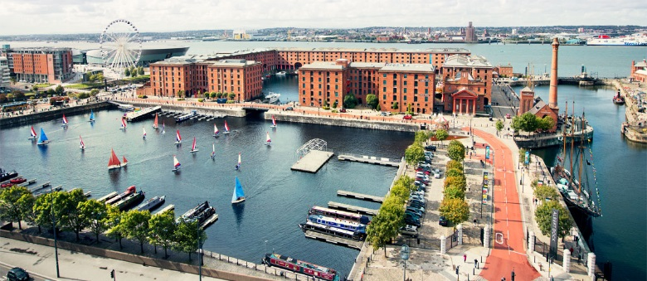
2b. How has redevelopment in the 1980s transformed the Albert Dock? Consider its function (what it was used for), type of jobs, land use. (4 marks)
Write your answer here…
Look at the promotional video for European Capital of Culture: https://youtu.be/44K9bfxMqOw (3min) and this link: https://planetgeogblog.wordpress.com/2020/04/09/culture-led-regeneration-in-liverpool/
In addition, read the Geography Review Article about “Rebranding Liverpool” (attached) to answer the Qs 3 & 4.

- Why was the European Capital of Culture in 2008 important for Liverpool? Explain how it brought lots of money into the city. (4 marks)
Write your answer…

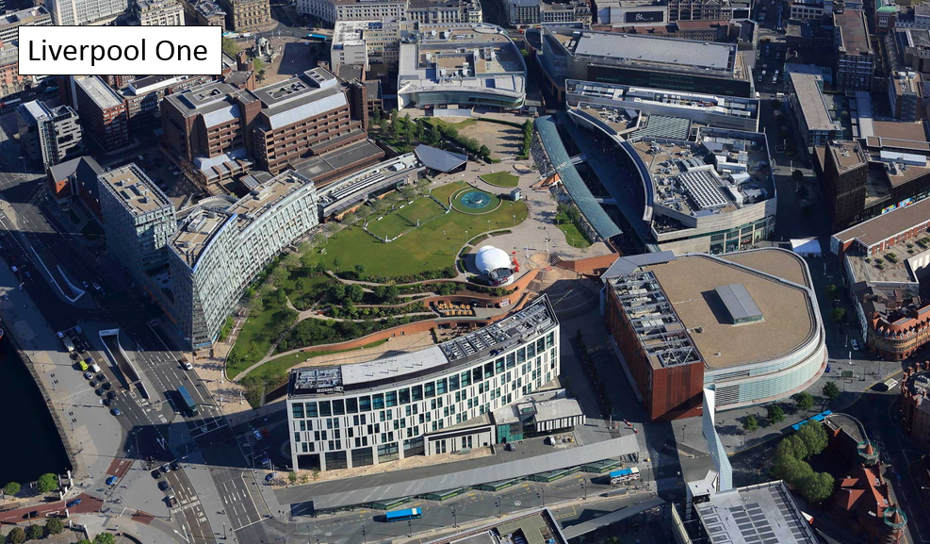
- Write four detailed facts about the Paradise Project (Liverpool One Project) that show that it is an important asset to the city. (4 marks)
Write your answer…

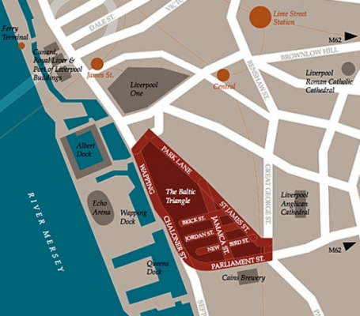
- Carry out some internet research about an area of Liverpool called the Baltic Triangle. Create an A4 information sheet that summarises how the area is being transformed.
Write a paragraph of at least 100 words for each of the following headings. Include photographs to bring your summaries to life. (9 marks):
- Industry (from secondary industry to tertiary/quaternary industries)
- Housing (new apartments, converted warehouses, type of people who live there)
- Leisure (nightclubs and bars, food market, cafes, events etc)
If you find out anything interesting that does not fit into the above categories then create your own category of extra information!
You may find some of these web links useful for your research:
https://baltictriangle.co.uk/baltic-creative-5-years-later/ (video: 8m)
https://baltictriangle.co.uk/bbc-cover-the-baltic-triangle/ (video: 2m 43s)
https://youtu.be/fjQXclBI_6M (Peaky Blinders – new bar launch - video: 2m 24s)
https://baltictriangle.co.uk/about/ (video: 9m 41s)
https://baltictriangle.co.uk/
https://www.visitliverpool.com/explore-the-city/neighbourhoods/baltic-triangle
https://www.visitbritain.com/gb/en/hipsters-guide-liverpools-baltic-triangle
https://theguideliverpool.com/these-are-the-hidden-treasures-of-liverpools-baltic-triangle/

