A-LEVEL PHYSICAL EDUCATION
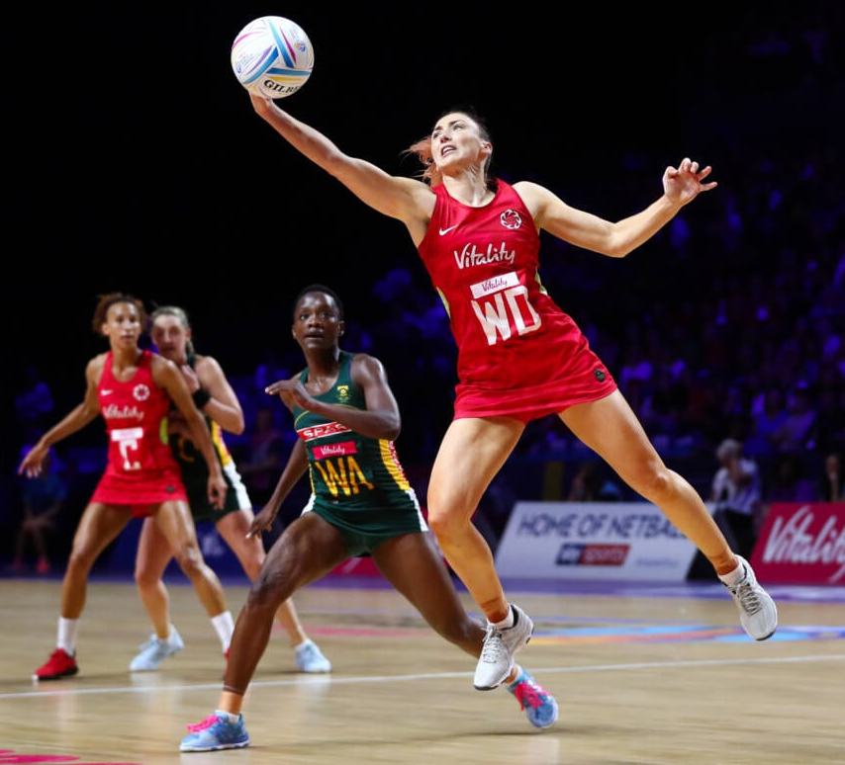

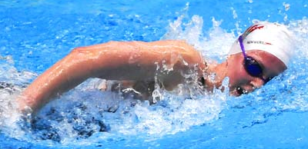

YEAR 11 TRANSITION
PROJECT

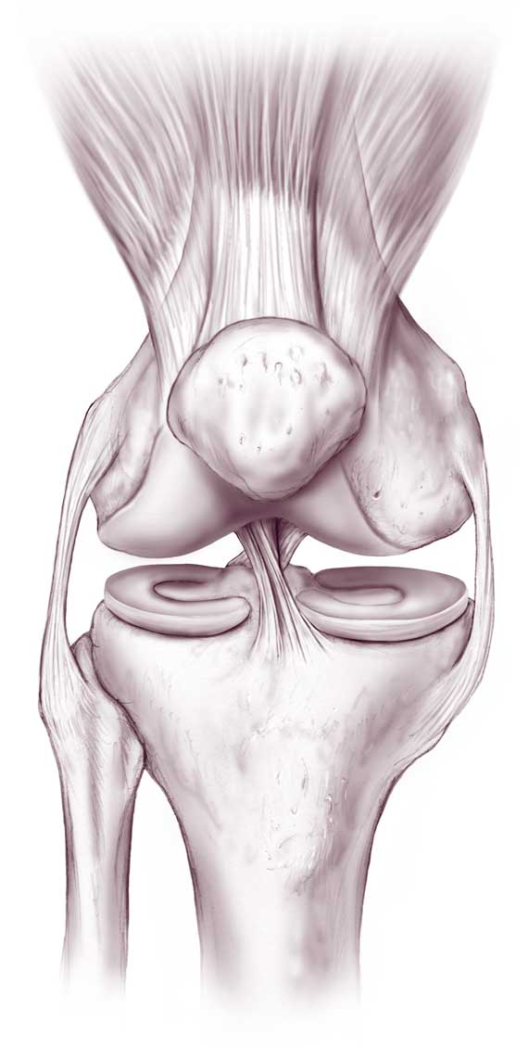
WELCOME TO A-LEVEL P.E. (Anatomy & Physiology)
TASK 1
As part of the Applied anatomy and physiology work, you are required to gain a detailed understanding of the skeletal and muscular systems.
On an A3 piece of paper design a factual poster of two major joints in the body. You should choose a joint from the upper body (shoulder, elbow or wrist) and a joint from the lower body (hip, knee or ankle).
Your poster, must include:
- An anatomical diagram of each joint.
- What type of joint it is ( e.g. hinge etc).
- The bones that articulate at the joint.
- The muscles that are involved at the joint.
- The movements that can take place at the joint (e.g. flexion etc).
- Explanation of the function of the components of a synovial joints (to include – ligaments, tendons, cartilage, synovial fluid, bursa and joint capsule).
- Give detailed practical examples of when the joint is used during sporting actions.

You can present your poster in any way that you would like. Make sure that your information is correct. You can include diagrams.
You will then be required to present this information during a lesson. Go to the OCR A-Level PE website. Then click on planning and teaching resources. There is also a very useful power point on the skeletal and muscular systems that would will help you. You will find it in the Topic exploration packs.

TASK 2

One part of applying the theory to a sporting performance, requires you to produce a movement analysis.
- For ONE skill from your main sport (e.g. shooting technique in netball, tennis serve technique or track start off the blocks in swimming etc), you need to identify the movement phases of the skill, e.g. the preparation, execution, recovery. Pictures of the phases will help you!!

- What you need to do for each phase? To identify …

- The movements that have taken place at each of the major joints e.g. flexion. There are some new movements that you haven’t come across before that you will need to research (they are horizontal flexion and extension at the shoulder, dorsi-flexion and plantar flexion at the ankle, medial and lateral rotation at the shoulder and hip joints)!!

- The agonist muscle.

- The antagonist muscle.

- The joint type e.g. ball & socket.

- The bones that articulate at the joint.

- The type of muscle contraction taking place (concentric, eccentric or isometric).

REMEMBER that more than one movement pattern may take place at each joint.

Use the tables to help you

SKILL__________________________________________
IMAGE OF PREPARATION PHASE

IMAGE OF EXECUTION PHASE

IMAGE OF RECOVERY PHASE

JOINT | JOINT TYPE | BONES AT JOINT | MOVEMENT | AGONIST | ANTAGONIST | TYPE OF CONTRACTION
Left Wrist
Right Wrist
Left Elbow
Right Elbow
Left Shoulder
Right Shoulder
Left Hip
Right Hip
Left Knee
Right Knee
Left Ankle
Right Ankle
SKILL _____________________________ PHASE____________________________

JOINT | JOINT TYPE | BONES AT JOINT | MOVEMENT | AGONIST | ANTAGONIST | TYPE OF CONTRACTION
Left Wrist
Right Wrist
Left Elbow
Right Elbow
Left Shoulder
Right Shoulder
Left Hip
Right Hip
Left Knee
Right Knee
Left Ankle
Right Ankle
SKILL _____________________________ PHASE____________________________

JOINT | JOINT TYPE | BONES AT JOINT | MOVEMENT | AGONIST | ANTAGONIST | TYPE OF CONTRACTION
Left Wrist
Right Wrist
Left Elbow
Right Elbow
Left Shoulder
Right Shoulder
Left Hip
Right Hip
Left Knee
Right Knee
Left Ankle
Right Ankle
SKILL _____________________________ PHASE____________________________

MOVEMENT ANALYSIS HELP TABLE
JOINT | JOINT MOVEMENT | AGONIST MUSCLE  (Concentric Muscle Contraction) | ANTAGONIST MUSCLE  (Eccentric Muscle Contraction)
WRIST | FLEXION | WRIST FLEXORS | WRIST EXTENSORS
 | EXTENSION | WRIST EXTENSORS | WRIST FLEXORS
ELBOW | FLEXION | BICEPS BRACHII | TRICEPS BRACHII
 | EXTENSION | TRICEPS BRACHII | BICEPS BRACHII
SHOULDER | FLEXION | ANTERIOR DELTOID | POSTERIOR DELTOID
 | EXTENSION | POSTERIOR DELTOID | ANTERIOR DELTOID
 | HORIZONTAL FLEXION | PECTORALIS MAJOR | POSTERIOR DELTOID/TERES MINOR
 | HORIZONAL EXTENSION | POSTERIOR DELTOID/TERES MINOR | PECTORALIS MAJOR
 | ABDUCTION | MIDDLE DELTOID | LATISSIMUS DORSI
 | ADDUCTION | LATISSIMUS DORSI | MIDDLE DELTOID
 | MEDIAL ROTATION | SUBSCAPULARIS & TERES MAJOR | INFRASPINATUS & TERES MINOR
 | LATERAL ROTATION | INFRASPINATUS & TERES MINOR | SUBSCAPULARIS & TERES MAJOR
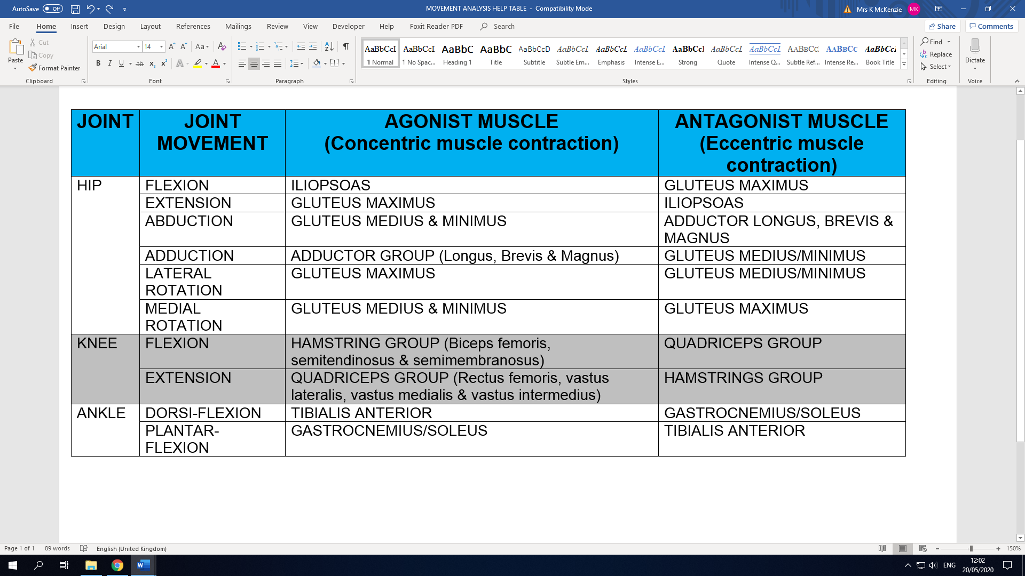

TASK 3
Complete the glossary table below – go to the OCR A-Level PE website. Then click on planning and teaching resources, click on teacher guides and open the glossary of terms to help you.
https://www.ocr.org.uk/qualifications/as-and-a-level/physical-education-h155-h555-from-2016/planning-and-teaching/

Abduction
Adduction
Agonist
Antagonist
Antagonistic muscle action
Concentric contraction
Dorsi-flexion
Eccentric contraction
Fast glycolytic muscle fibres
Extension
Fixator
Flexion
Horizontal extension
Horizontal flexion
Isometric contraction
Joint
Plantar flexion
Rotation
Slow oxidative muscle fibres
Tendon

