HISTORY A-LEVEL TRANSITION WORK

- READ
Contextual details: Microsoft Word - 3A1A55AC8C967FCAEEE4B84A6F97AA9A.docx (lfatsf.org.uk)

SOURCE: Winston Churchill speech. The Stadium, Liverpool on October 2nd 1951

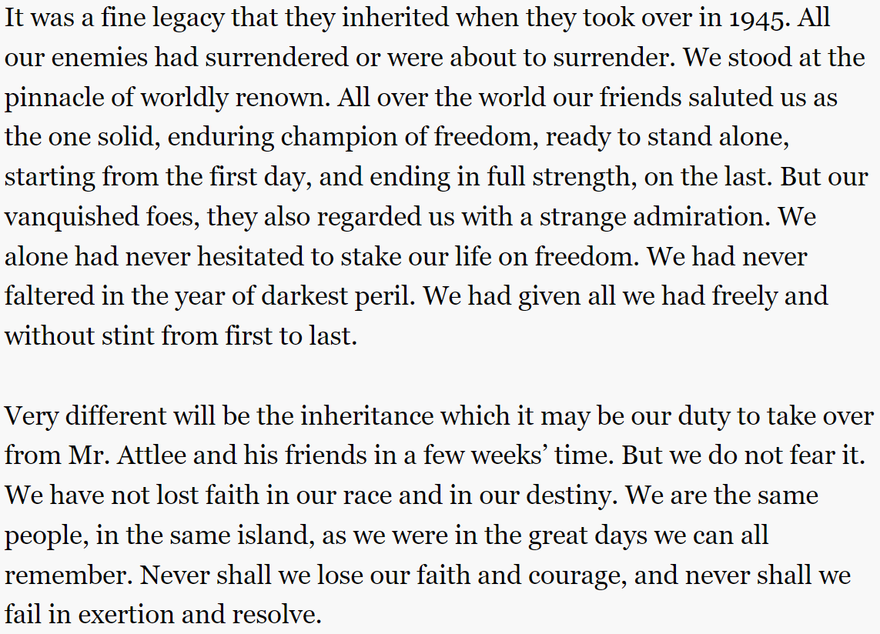

Consider the provenance as well as the key messages contained within this source.
Apply contextual knowledge too (follow the link).

THINK: What is this source suggesting about Britain’s position in relation to foreign policy?

- ‘LISTEN OR WATCH’
Watch: Churchill In The USA (1952) - YouTube
Listen: The Presidents & Prime Ministers - Podcast (globalplayer.com)

- QUESTION
‘Winston Churchill was more interested in playing the role of world statesman than the role of prime minister between 1951 and 1955.’ Assess the validity of this view.

- ‘TRY’
Write a side of A4 answering the question above applying all that you have learnt in stages 1 and 2. You can also carry out additional research.

Bring this piece of work with you to your first lesson in September.

