EUROPE SHAPED BY ICE Name:
A brief intro into the topic of glaciation for A1 students. .
This material was originally designed in May 2020 to introduce Key stage 3 students to the new topic of glaciation. As this topic will probably be a new topic to most of you (it has never been studied at WKGS in either KS3 or KS4 before) we have revamped it, so it provides a really useful introduction to the topic for KS5 students. The answers to the activities - which are added to the sheet (so you need to fully download it) are designed to get you thinking. At A level we study Glacial landscapes from around the world, this activity uses examples from Europe to get you started. As you add notes do not worry if the text and pictures are pushed down the page. For those who can access iPupil there is further material there. Please email kvane@wkgs.net if the video links do not work.
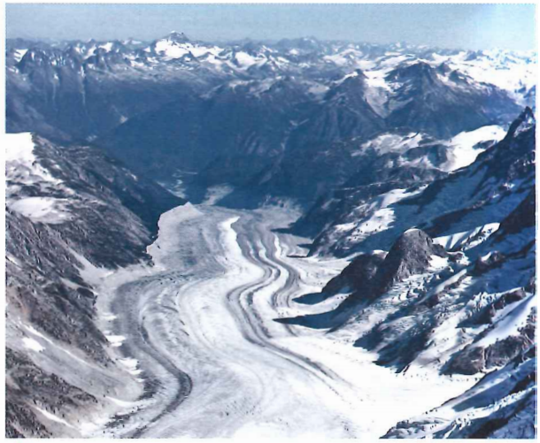
What is a glacial environment?
It’s hard to believe that Northern Europe and much of the UK once looked something like this photo in the Alps.
During the last ice age snow and ice covered much of the landscape. Temperatures barely rose above freezing even in the summer!
Note the feature with the stripes on it is called a glacier. A thick mass of ice maybe 300 to 400m thick in parts!
Huge glaciers radiated (moved out) from the north and carved deep glacial valleys know as troughs.
Further south and east the land was permanently frozen (known as periglacial conditions) with some meltwater rivers.
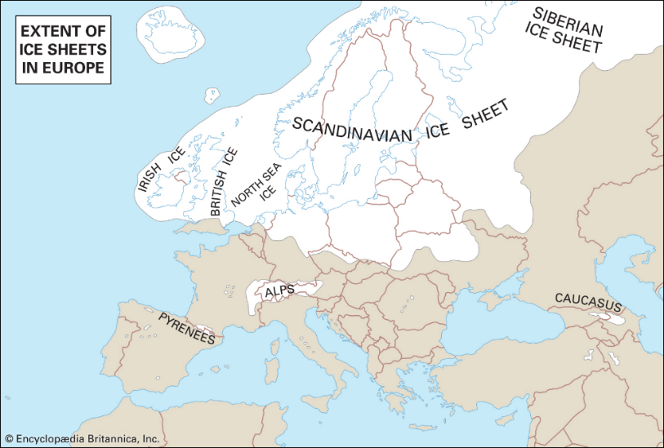
This map shows the areas that were covered by ice during the last ice age 18,000 years ago.
Q1. How far south did the ice sheets extend in the UK? (look carefully at the map and mention a present- day city – though of course it was not there during the Ice Age.

Q2. In this space can you add a picture from internet research as to what the UK and Europe looked like during the last ice age.

Watch this video from National geographic in the US as an intro: https://youtu.be/WJgpDyP9ewQ
Today the cold environments in Europe are limited to the Alps, the extreme North of Scandinavia (near the North Pole) and in Iceland. There places contain huge masses of ice called ice sheets, ice caps and/or glaciers.
3a. Undertake some research to find a definition for
An ice sheet.

An ice cap.

A glacier.

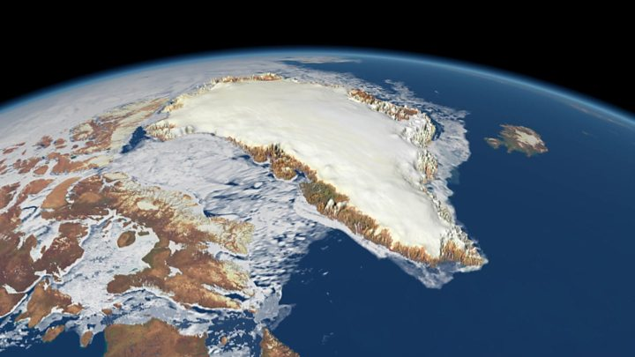
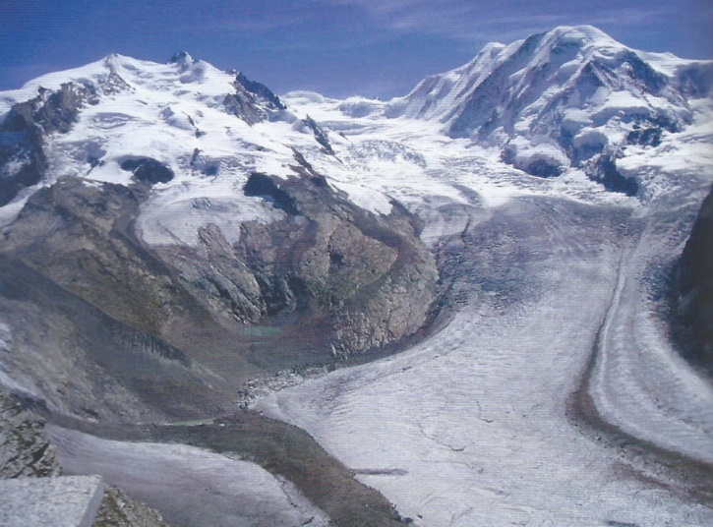
3b These two photos (A is Zermatt in Switzerland and B is Greenland) show either an ice sheet or a glacier – which is which?
B
A

A = B =
3c. Ice sheets do not exist in Europe today but there are ice caps – can you find out where the largest ice cap in Europe is? How big is it in terms of area?

3d Zermatt is a very exclusive place for tourists, but it is car free so what transport do visitors use to get to Zermatt once they are in Switzerland. Maybe add a picture?

How do we know what happened in the past during the last ice age?
Glaciologists are scientists that study glaciers, ice caps and ice sheets to find out about climate change.
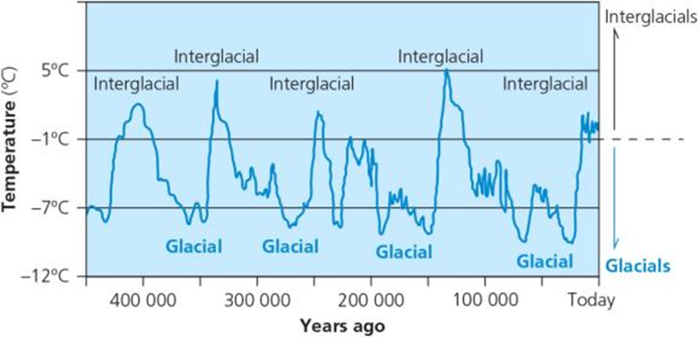
They have discovered that global climate has changed in the past, as shown on this graph.

Q4a. Look at the graph to try and work out what a glacial is and what an interglacial is. CLUE use the side axis

Q4b. Is it true that hippopotamus bones found in central London suggest an interglacial?

Ice ages are when temperatures are low enough for ice to form ice sheets and glaciers. This cause polar ice to move southwards into the ‘lower latitudes’ as seen on the map on page 1.
Scientists believe that there have been a number of ice age cycles. During the last ice ages , the world was an average of 5°C colder than today. During this time, ice covered up to 30% of the world. That does not mean to say that if the temperature drops by 5°C tonight that we will get ice sheets. No, the temperature has to be 5°C less all year and for many years.
So how do we know that the climate has changed?
- By taking core samples from existing ice sheets and looking at the chemical composition of the ice (and the marine organisms trapped in it at different depths), scientists can work out changes in temperature over the last few thousand years.
- Gas bubbles in the ice can also show what the atmosphere was like at the time, especially the amount of CO₂ (carbon dioxide).
- Some of the landforms found in Britain today, e.g. valleys in Highland Scotland, Snowdonia in Wales and the English Lake District, could only have been formed by ice. Pinpointing where the ice sheets reached.
Q5a. Find pictures on the internet that you can cut and paste here to support the above pieces of evidence.
Add some further notes or even useful article references for you to come back to later when we study the topic in depth.

Q5b Are there any other indicators of climate change. Some words to look at include dendrochronology; lake sediments called varves, pollen analysis. Select one or two and put a brief note here about it together with an annotated picture. (Remember you can write a caption under a photo to sav time)

Ice in the world now? Currently about 10% of the Earth’s land surface is covered in glacial ice - much of it in Antarctica and Greenland.
For the last 150 years, ice sheets and glaciers all over the world have been melting and becoming smaller. Sadly, in the last 20 years - the rate of melting has really speeded up. Scientists believe that this increased melt rate is due to rising global temperatures especially caused by manmade (anthropogenic) greenhouse gases causing global warming.
Q6. Outline the issues that are raised in this last sentence.

This map shows the world distribution of ice sheets and glaciers.
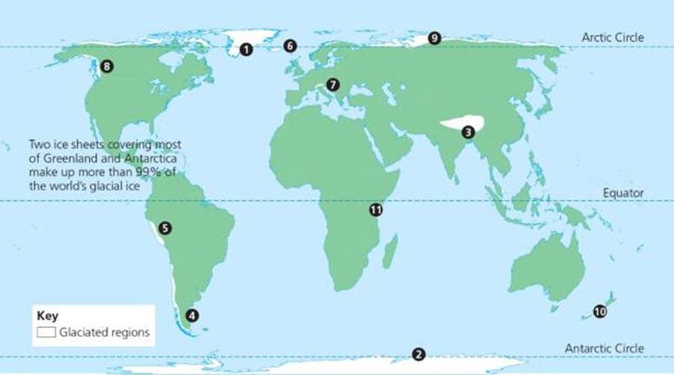
Q7. Compare this map with an atlas map of the world and try to match the following cold places with their correct number location. The only two with ice sheets have been done for you.

Greenland [1] ; Antarctica [ 2 ] both have huge ice sheets
Alaska – glaciers; [ ]
Himalayas – glaciers; [ ]
Iceland – glaciers; [ ]
New Zealand – Fox glacier; [ ]
Russia – glaciers; [ ]
Andes – glaciers; [ ]
Mount Kilimanjaro – glacier. [ ]
Alps – glaciers; [ ]
Perito Moreno, Argentina – glacier [ ]
This weblink mentions one of these places Perito Moreno in Argentina where the glacier is actually not shrinking. Click and read. https://www.nationalgeographic.com/travel/destinations/south-america/argentina/perito-moreno-glacier-collapse-video-argentina-patagonia-spd/
EUROPE SHAPED BY ICE PART 2.
How do glaciers form and move?
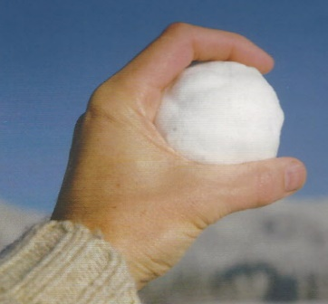
Glacial ice forms in upland or polar areas above the snowline. Here snow and ice cover the ground throughout the whole year. It many years for snow to become glacial ice.
From snowball to glacier
We've all made a snowball by squeezing the snow in our hands until it becomes hard and solid. Ice forms at the bottom of a glacier in exactly the same way - newly fallen snow each year compresses the previous year's snow below. The individual snowflakes are compacted into smaller particles of ice, which stick together to form larger granules - called firn or neve. With more snow falling each year, eventually the firn is compressed to form solid glacial ice.
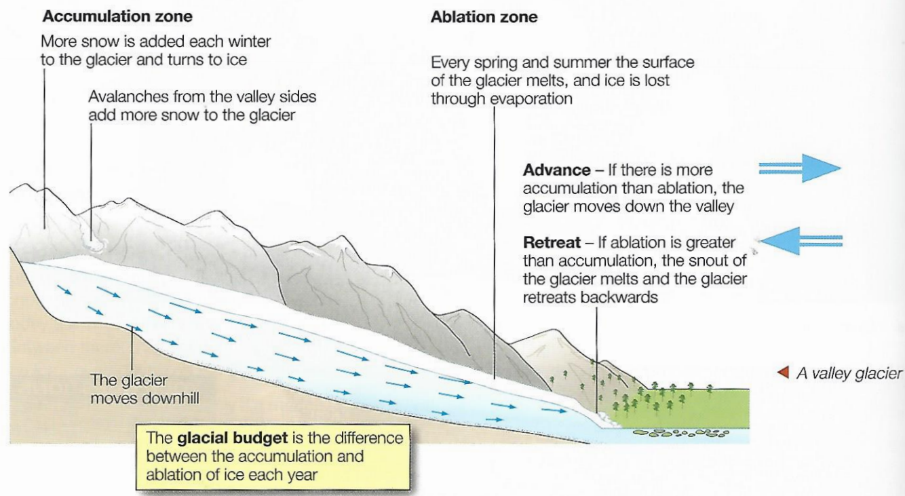
As snow accumulates (gains ice), it is compressed by its own weight. Gradually, dense hard ice forms and starts to flow down-slope under its own weight. Where more ice is gained than lost over a year , it is called the zone of accumulation. If the temperatures remain low, with heavy snowfalls, glaciers advance down-slope.
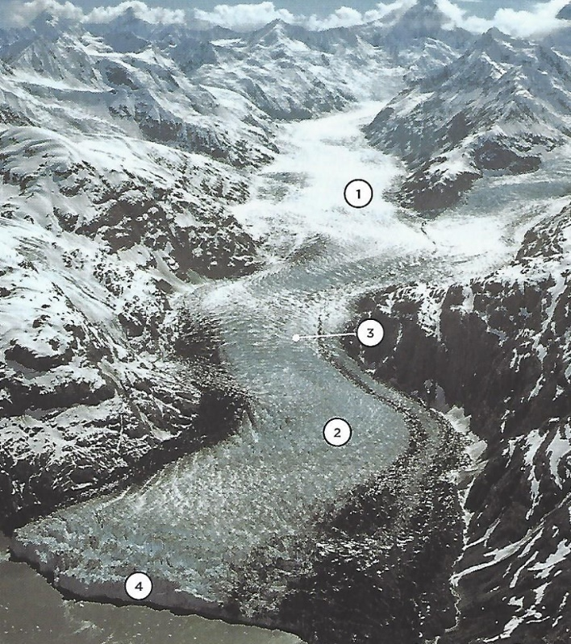
If accumulation (the amount of ice gained) is greater than ablation (melting), then the amount of ice stored in a glacier reduces in size and retreats. This occurs in the zone of ablation – where the glacier ends. The ice can move at different speeds. This creates wrinkles in the surface of the ice, forming great cracks called crevasses.
The end of the glacier is called the snout. This is where the main output from the glacier – water – is released. During the last century, most glaciers around the world have been shrinking and retreating. This is due to warmer, drier climate conditions.
Q8a. Using the diagram above and the writing, as well as looking at this photo of a glacier – state the names of:
Zone 1:
Zone 2:
Glacial feature 3: (CLUE speed)
Glacial feature 4:
Q8b State what is actually happening at each

The Mer de Glace
Watch the short clip on the Mer de Glace at https://youtu.be/kWxgu4qWOBY Be sure to have the sound up.
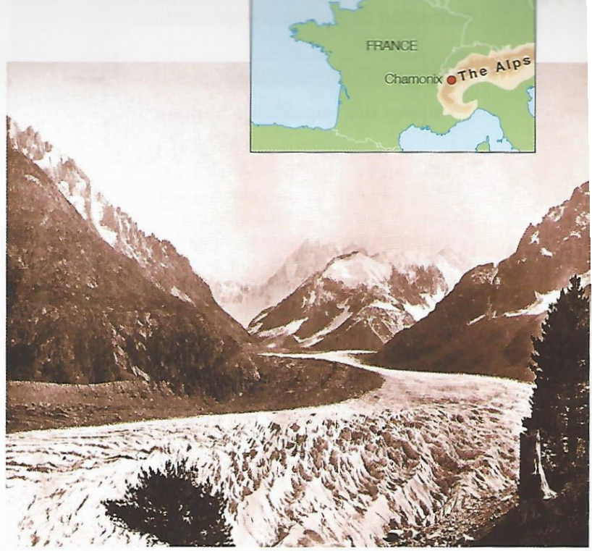
Take a look over the glacial hub blog at https://glacierhub.org/tag/mer-de-glace/ You can supplement the notes that follow with updated information from the blog.
The shrinking Mer de Glace (Sea of Ice) glacier in the French Alps is retreating. Since 1850, it has become much shorter and thinner. Although in the 1970s and 1980s it actually advanced by 150 metres, it's now retreating again by about 30 metres a year (it's already 500 metres shorter than it was in 1994).
The Mer de Glace:
- is the largest glacier in France
- is 7 kilometres long and 200 metres deep
- flows NNW from Mt Blanc towards Switzerland
- is close to Chamonix.
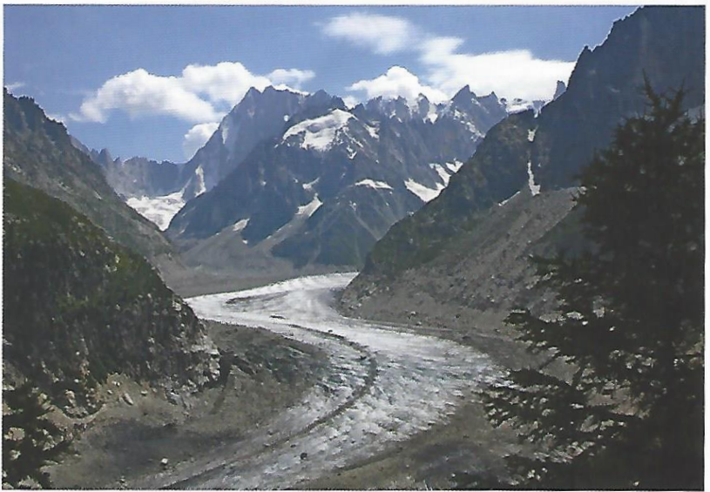
How do we know that the Mer de Glace is retreating?
Nineteenth-century paintings and photographs, like the one (from an old postcard) on the top right, show how much deeper and wider the glacier used to be. Compare this with this photo from 2008.
Aerial photos and satellite images show recent changes in the position of the glacier. While old maps from a century ago show the extent of the ice at that time.
Debris, called moraine, left by the glacier on the valley's floor and sides as it retreats, shows how much longer and wider it used to be.
Why is the Mer de Glace retreating?
Records show that average temperatures in France have risen by 1°C in the last 100 years. But above 1800 metres (i.e. up in the mountains of the Alps), temperatures have risen by 3°C in the last 40 years.
Not only that, but winters have become drier - especially the winters of 1989, 1993 and 2002. In the mountains, a drier winter means less snowfall. So, while a glacier would normally advance in the winter and retreat in the summer, the combination of warmer winters and normal summer melting means that glaciers like the Mer de Glace are retreating (getting smaller) all year round. As a result, scientists believe that there is a direct link between retreating glaciers and climate change.
Q7. Briefly state how and why the glacier has retreated with some data to support your answer. Start by comparing the two photos. Will the situation improve or worsen?

ICE IN EUROPE PART 3. How do glaciers shape the land?
Ice is a powerful force. It shapes the land using the processes of erosion, weathering, transportation, and deposition - carving out landscapes and creating distinctive landforms. It helps to create spectacular scenery worth seeing.
Weathering processes in cold environments
Weathering involves rocks being broken down ‘where they are’ or ‘in-situ’. There are different types of weathering but in a cold environment the main type is freeze-thaw activity. The amount of liquid water is limited due to the freezing temperatures, but in summer melted water flows into cracks in the rocks and freezes hard the following winter. Everyday there is some freezing and thawing taking place, but it is especially common when the temperature difference between day and night moves above and below 0°. This is called the diurnal range
Q8. Research (look up) how freeze thaw weathering breaks up a rock face or cliff. A series of pictures is usually a good way of showing freeze thaw weathering.
Freeze-thaw is an important process in glacial environments because:
- it helps to shape jagged glacial mountain landscapes.
- rocks become weakened by freeze-thaw making it easier for them to be eroded by glaciers.
- piles of large angular rocks, called scree, collect at the foot of mountains - these become powerful erosion tools when trapped under moving glaciers.
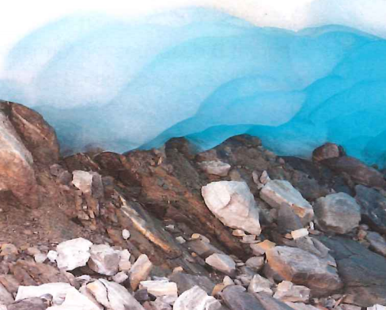
ADD YOUR FINDINGS HERE (Don’t worry if all the text gets pushed down):
The processes of glacial erosion
Glaciers usually move very slowly - only a few centimetres a year but they are responsible for an incredible amount of landscape erosion. There are two main types of glacial erosion: abrasion and plucking.
This plucked rock debris becomes embedded at the base and sides of the glacier. As the ice moves forward, these rocks scrape against the bedrock, wearing it away. See photo on right. This is called abrasion, the ‘sandpaper’ effect caused by the weight of the ice scouring the valley floor. It leaves behind smooth, polished rock surfaces, which may have scratches in them called striations caused by large rocks beneath the ice.
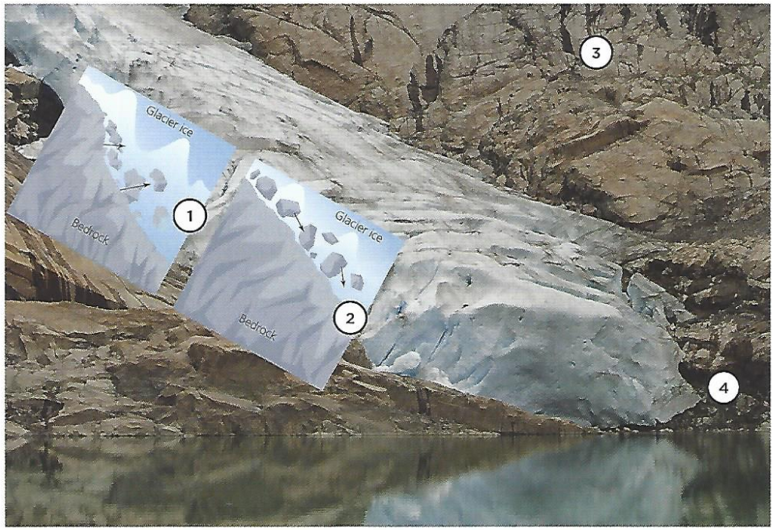
Plucking is when meltwater beneath a glacier freezes and bonds the base of the glacier to the rocky surface below, rather like when your fingers stick to an ice cube. As the glacier moves, any loose fragments of rock will be ‘plucked’ away-like extracting loose teeth! Plucking leaves behind a jagged rocky surface.
9a. Look carefully at the bottom photo, what types of glacial erosion are shown at 1 and 2. For each justify your answers with evidence.

9b. What process happens at 3 (note the earlier notes) and what is happening to the glacier at 4?

ENSURE YOU UNDERSTAND:
Weathering of rock (breaking it apart) is different to erosion (wearing the rock away with an agent like ice or water.
Two types of erosion are plucking and abrasion.
How a glacier creates deep valleys.
Watch these very simple intro videos: https://youtu.be/loI584OFVpE https://youtu.be/NH-vnKR6A7A you can add any notes here:

These three diagrams show how ice can build up on the shaded side of a mountain. This is due to aspect. A hollow starts to form due to a process called nivation.
10a Research and state briefly what the terms aspect and nivation mean.
This snow patch eventually is compressed into ice and then starts to flow. As the ice builds up in the hollow, the increased weight of ice and movement down-slope leads to the ice gouging and deepening the hollow. Years later this might fill with water and is called a tarn. This bowl-shaped feature is called a corrie (in Scotland), cwm (in Wales), or a cirque (in France).
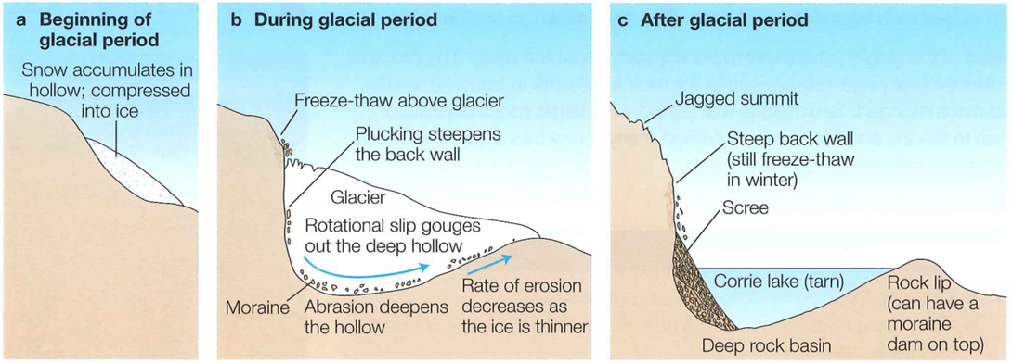

Where two corries develop side by side, the glaciers erode the rock between them leaving a knife-like edge called an arête. When three or four corries develop around a mountain top, a pyramidal peak is formed. See the bottom picture on the right.
10b. Using google locate a picture of a corrie/ cirque or cwm.
Write a paragraph to explain how corries form. Look at the above three pictures plus the videos and research. Use as much technical geography vocabulary as you can.

10c Research on google a photo of the Matterhorn in the Alps. Add it here. Give its location in Europe and try to label corries/ cirques and arêtes and any other features you have learnt about on the picture.

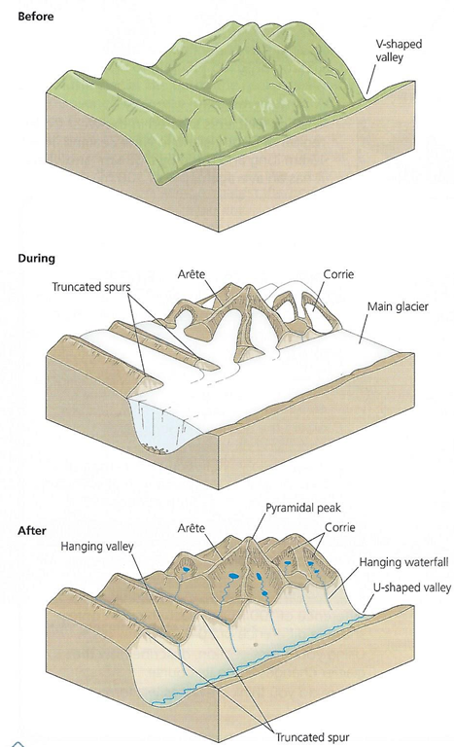
Watch: https://youtu.be/OIlYYOA70U4
During glacial periods in the last ice age, ice caps covered mountain areas. River valleys were slowly filled by moving ice which straightened and deepened them. These 3 diagrams show how such landscapes changed, in three stages - before, during and after glaciation.
11. Produce an A4 photo essay of pictures showing views of glaciers in corries and valleys similar to the middle picture, as well as adding some annotated or titled examples of all the features shown in the bottom picture.
If you have been to Iceland or the Alps (or even elsewhere in the world like the Rockies) , now is the time to use those photos you may have taken of some great landscapes (those without family or mates standing in front of the feature- though they might add ideas of scale!!)

Turn over
How are landforms shaped by glacial deposition?
Deposition landforms are formed when glaciers melt and start to drop all the debris (rocks of all different sizes and types), called moraine, that they have been transporting or carrying.
Glaciers and ice sheets carry huge amounts of debris, ranging from boulders as big as houses, pebbles, gravels, sands right down to fine clay particles. At the snout (front) of the glacier, the ice melts, so this material can no longer be carried by the ice. It is therefore dumped or deposited. This rock debris is called glacial till. It is also known as boulder clay showing that it is often a random mixture of boulders, rocks, sand and clay.
Most of this deposition takes place in warmer lowland areas. As the glacier melts, this lowland area is covered in a thick layer of till, so thick it buries the old landscape. Two main groups of landforms are then created as a result:
- those formed and dropped (deposited) directly from ice (VERY ANGULAR AND SHARP in shape)
- those formed and dropped (deposited) from the meltwater that flows from the melting glacier. (ROUNDED)
Remember a rock in the wrong place, miles away from where it fell off a cliff, is known as an erratic. (Look up the other definition of this word- there is a similarity.
Thurstaston cliffs between Caldy and Heswall on the Wirral, contain rocks that have been moved by glaciers all the way from the Lake District. One example is ‘Shap Granite’ containing pink crystals. The cliffs are made of boulders and clay called glacial till. They are easily eroded by the sea.

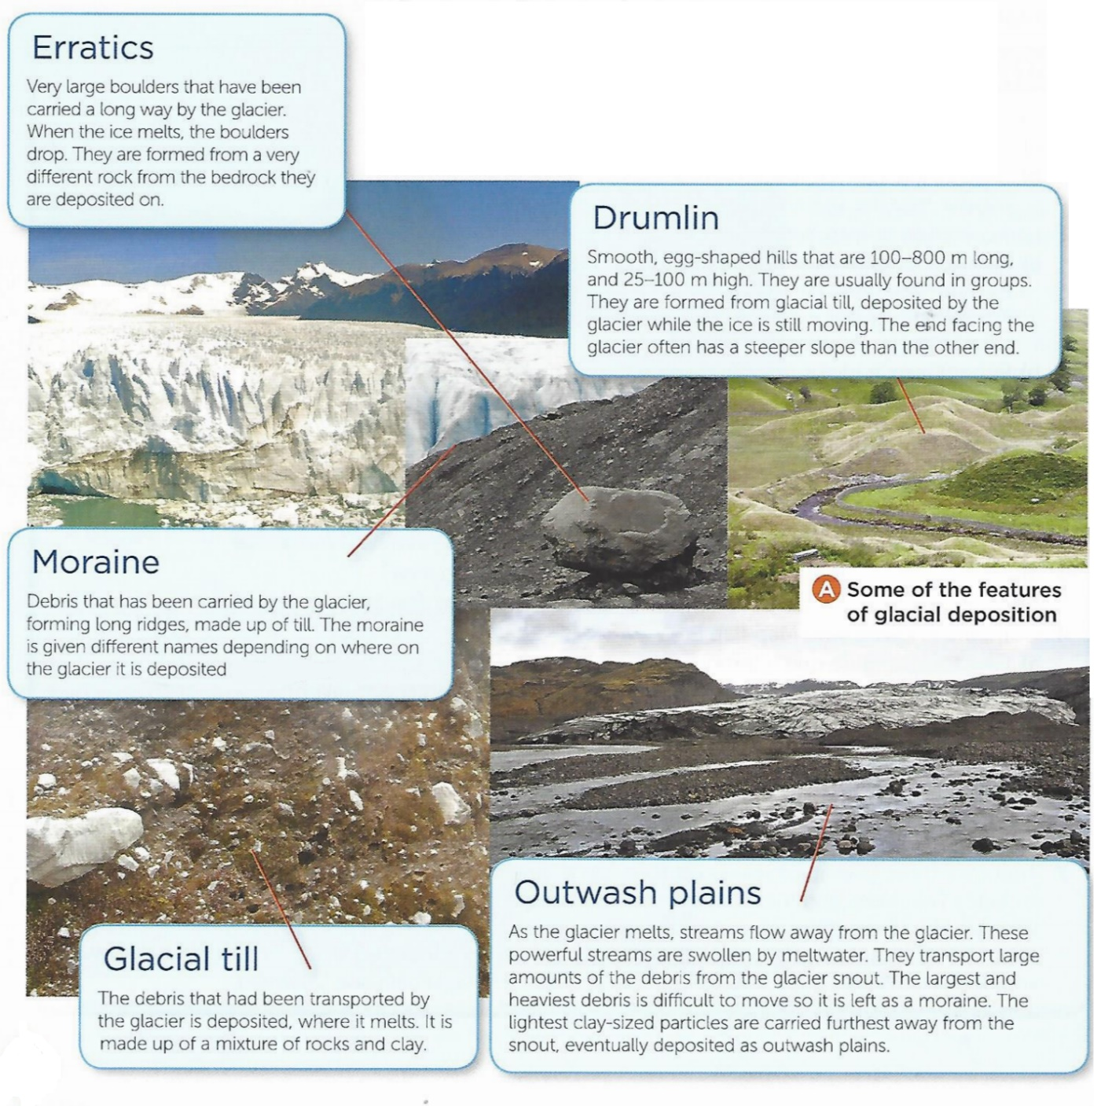
Q12. Where does the glacier melt? (CLUE: You may need to check back to the material and the term ablation as well as the term for the front or end of the glacier)
Q13. Can you suggest why rocks carried by a glacier are often very sharp and angular, while rocks carried by the meltwater rivers flowing above or under the glacier are often very rounded in shape?

What are the distinctive glacial deposition landforms?
Glaciers behave like giant conveyor belts carrying weathered and eroded rocks from the mountains to the lowlands. These rocks can be carried on top of the ice, within the ice (buried by layers of ice and snow) or beneath the ice where they carry out the process of abrasion. The term moraine is applied to these angular and poorly sorted deposits.
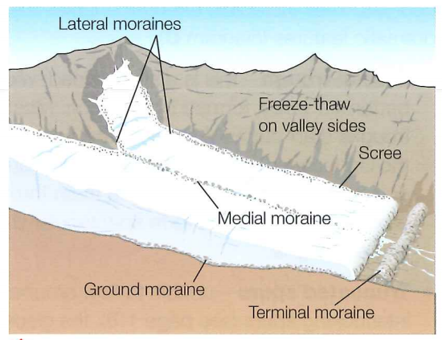
When deposited by the melting ice this sediment can form a blanket of material up to several metres thick. Geologists refer to this deposited material as till or boulder clay (as seen at Thurstaston cliffs), due to the range of sizes of the sediment.
Moraine
It is possible to identify several types of moraine:
Ground moraine - The material dragged underneath the glacier and left behind when the ice melts. It often forms uneven hilly ground.
Lateral moraine - This moraine forms at the edges of the glacier. It is mostly scree material that has fallen off the valley sides due to freeze- thaw weathering. When the ice melts, the moraine forms a low ridge on the valley side.
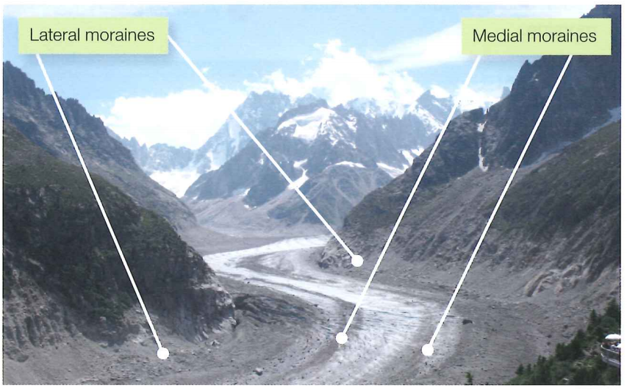
Medial moraine - When a tributary glacier joins the main glacier two lateral moraines will merge to produce a single line of sediment that runs down the centre of the main glacier. On melting, the medial moraine forms a ridge down the centre of the valley. The photo shows medial and lateral moraines on the Mer de Glace glacier in France. Imagine how these will look on the valley floor when the ice finally melts.
Terminal moraine - Huge amounts of material pile up at the snout of a glacier to form a high ridge often tens of metres in height across the valley. This is a terminal moraine. It represents the furthest extent of the glacier’s advance, hence the name ‘terminal’. See the diagram above.
As the ice melts and retreats up the valley many of these features are eroded away by meltwater. This explains why there are few such landforms evident in the UK today.
13. PHOTO ESSAY Select 3 or 4 photos of glaciers in the Alps, Pyrenees, or Iceland or use pictures you have already selected before. Where possible, add labels (or if this is not possible write annotation beneath them) outlining what depositional types of landform mentioned above in the text can be seen.

From GCSE make the link to volcanoes/earthquakes and in particular the Theory of Plate Tectonics. Alfred Wegener and his Continental Drift idea was partly based on the direction of striations in rocks in the southern hemisphere. LOOK BACK.

