Film: Room at the Top (1959)
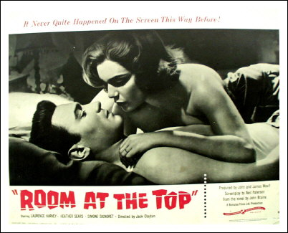

Ruthless young working-class Englishman, Joe Lampton (played by Lawrence Harvey), takes a job in a North Country village controlled by millionaire, Mr Brown. Lampton resents Brown's class consciousness and vows to rise to the top by wooing the millionaire's daughter, Susan (played by Heather Sears). Meanwhile he has an affair with Frenchwoman, Alice, (played by Simone Signoret). Though he regards Alice as a mere self-gratifying conquest, she takes their romance seriously enough to kill herself when Joe impregnates another woman. Only as he leaves the chapel after marrying the millionaire's daughter does Joe realise that his "smart" marriage, coupled with the guarantee of a fabulous business career, has been attained at the cost of his soul. Based on the novel by John Braine, Room at the Top was one of the most successful films of the British angry-young-man school; it later spawned two sequels, as well as a weekly TV series.

