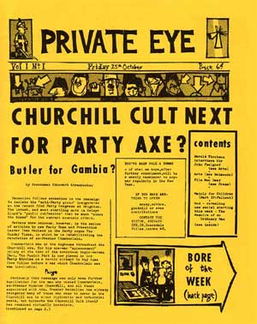
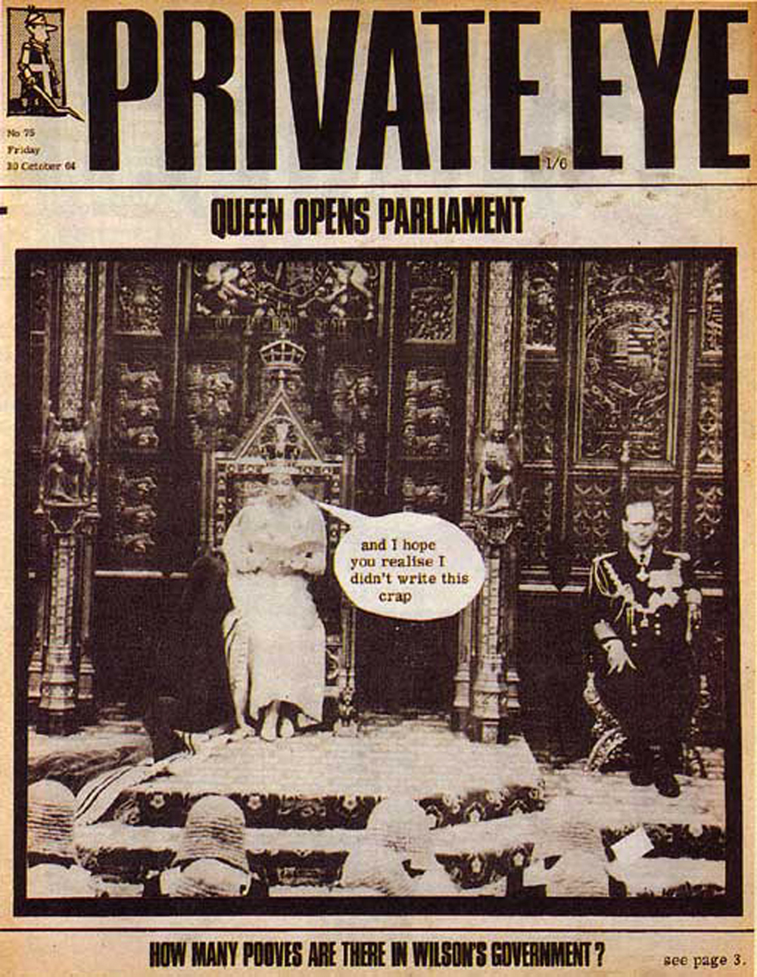

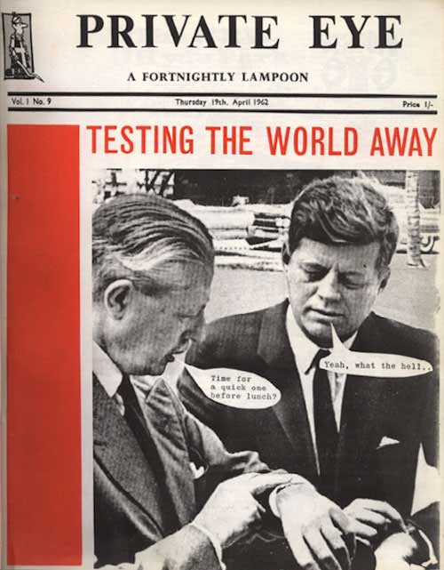

Task 1: Find out what news these front pages are satirising.
Task 2: Find a picture from the time and satirise it yourself with some speech bubbles or captions. Best one gets a prize.
