The Festival of Britain, was one of the last acts of Clement Attlee’s postwar Labour Government (1945-51). Deputy Prime Minister at the time, Herbert Morrison (Grandfather of New Labour’s Peter Mandelson, overseer of the Millennium Dome project in 1999), turned the Festival from being a laughing-stock, into an event that was generally considered a success by newspapers and public alike. Whilst its primary aim was, as Morrison put it, ‘for the people to give themselves a bit of a pat on the back’ for their war-time sacrifices, it was also intended to show the world that despite being heavily-weakened by the war and losing its position as a world superpower, it was still a pioneer in areas such as architecture, science and industry.
The Festival of Britain, Summer 1951
Although the main event was hosted in London where the flying-saucer-like Dome of Discovery (see picture) was situated opposite parliament, there were exhibitions up and down the country, including village pageants, ships visiting sea ports and even a netball exhibition in Colchester. In total, 8.5 million people visited the exhibition in the Thames with a further 8 million visiting the accompanying funfair further down the Thames in Battersea.
With the benefit of hindsight though, the event appears to be something of a last hurrah, not only of the outgoing and weary post war Labour government but it also, perhaps, says something of Britain’s self-delusion of its own world standing at a time when it was out of money, still in the midst of rationing and increasingly reliant on American aid.
As Michel Frayn of the Manchester Guardian put it at the time, the festival could be ‘…likened to a gay and enjoyable birthday party, but one in which the host presided from his death bed’. Put it down to either typical British dry-witted cynicism or a realistic assessment of Britain’s plight, but there was a joke doing the rounds in 1951 that the Skylon (see picture) looked like it was suspended in mid-air….just like the British economy.
The festival itself was designed to show off the best of British industry, technology and culture and whilst Morrison certainly spoke of the festival being for the British people, the feeling was that it was largely motivated by a desire to prove Britain’s worth on the global stage. In terms of its lasting contribution, Winston Churchill (whilst in his second term in office) as well as politician and historian Peter Hennessy note that Festival was ‘Trumped in popular perception and memory’ by the coronation of Queen Elizabeth II, just two years later in 1953.
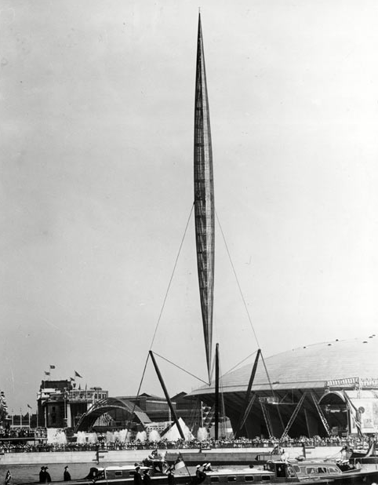
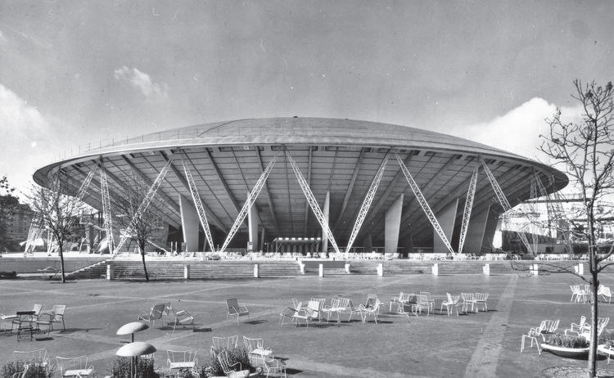
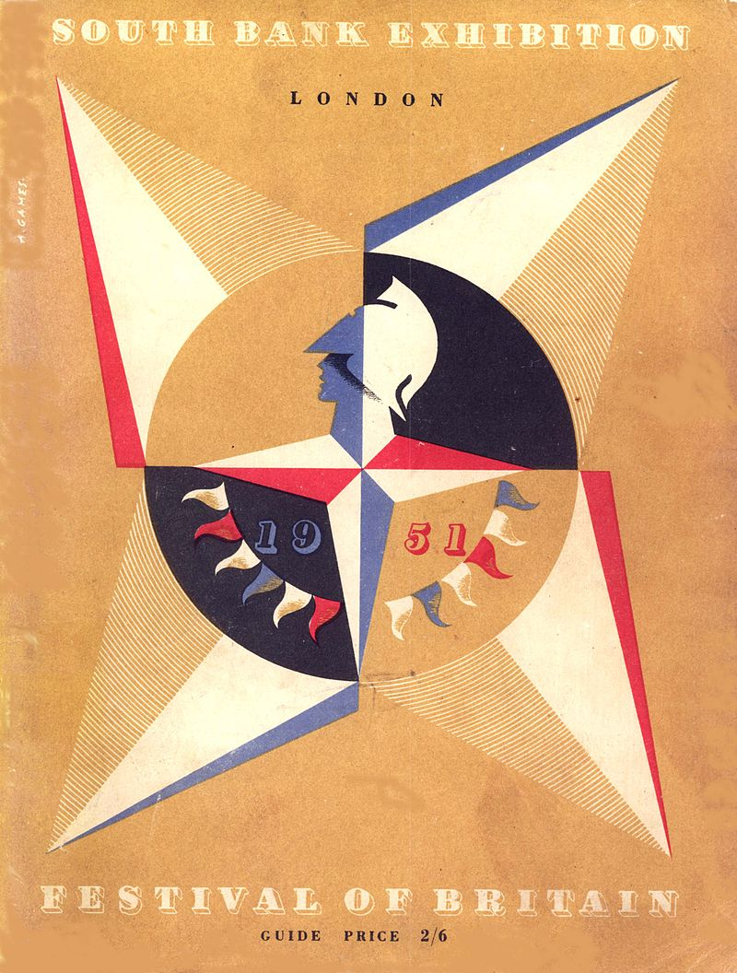
The Skylon, symbol of the Festival of Britain
The Dome of Discovery by architect Ralph Tubbs
The Festival of Britain emblem – the Festival Star – designed by Abram Games, from the cover of the South Bank Exhibition Guide, 1951
The Festival of Britain 1951

