Hola a todos
vais a estudiar el español
¡qué bien!

CONTENTS PAGE

INTRODUCTION 2
COURSE CONTENT 3
GRAMMAR 4
A BRIEF HISTORY OF SPAIN 5
THE FILM AND THE LITERARY TEXT 7
STAYING FLUENT 8
CURRENT AFFAIRS 12
ART 13

INTRODUCTION
Spanish is one of the most influential languages in the world and is the 2nd most common native language in the world, with 480 million speakers.
Studying A Level Spanish will give you in-depth knowledge of the Spanish language and an insight into the artistic and cultural heritage of the Spanish speaking word and its most recent political and social changes.
This booklet introduces the A Level Spanish course and provides different ways to keep up the language skills that you have acquired at GCSE and to learn more about Hispanic culture and society.
Use this booklet to dip in and out over the summer break.

¡A practicar¡

COURSE CONTENT
Here is the link to the AQA A Level Course:
http://www.aqa.org.uk/subjects/languages/as-and-alevel/spanish-7692
Year 1 AS LEVEL
- Aspects of Hispanic Society: modern and traditional values, Cyberspace and Equal Rights
- Artistic Culture in the Hispanic World: modern day idols, Spanish regional identity and cultural heritage
- The study of the film, El Laberinto del Fauno by Guillermo del Toro.

Year 2 A LEVEL
- Multiculturalism in Hispanic Society: immigration, racism and integration
- Aspects of Political Life in the Hispanic World: young people today, monarchies and dictatorships and popular movements
- The study of the literary text, La Casa de Bernarda Alba by Federico García Lorca

The core grammar from GCSE is revised and consolidated and more advanced structures are introduced to enable you to communicate over the wide range of topics contained in this course.

GRAMMAR

A firm grasp of Spanish grammar is essential at A Level and all GCSE grammar needs to be revised for A Level.

There is a 2020 Grammar Practice GCSE Workbook prepared for you to revise all GCSE grammar.

If you prefer you can practice grammar online using the links below:

Languages Online
https://www.languagesonline.org.uk/Hotpotatoes/spanishindex.html#Grammar

Kerboodle - Resources
Type in the tense that you wish to practise and click on the interactive activity.
https://www.kerboodle.com/app/courses/34628/modules/resources

A BRIEF HISTORY OF SPAIN
(9 minutes)
https://www.youtube.com/watch?v=nPcfZLaMoAo
(10 minutes)
https://www.youtube.com/watch?v=05_tghbhlfM
KEY DATES IN SPANISH HISTORY
1100 BC. Phoenician traders establish colony at Cádiz in southern Iberia.
228 BC. Carthaginians occupy southern and eastern Iberia.
218-220 BC. Romans defeat Carthage in Second Punic War and occupy Iberian Peninsula.
409. Visigoths occupy Iberian Peninsula.
711. Combined Arab and Berber force from northern Africa cross Strait of Gibraltar to occupy Iberian Peninsula.
913. Having re-taken territories in northern Spain, Christians establish capital in León.
1013. Powerful Caliphate of Córdoba breaks up due to internal strife; Moorish Spain split into small feuding kingdoms.
1212. Decisive Christian victory at battle of Navas de Tolosa spells the beginning of the end of Moorish rule in Spain.
1492. King Fernando and Queen Isabel's army capture Granada after a long siege, the final defeat of the Moors in Spain. Jews are forced to convert to Christianity; those who refuse are expelled from Spain. Christopher Columbus sets sail on his voyage of discovery.
1588. Defeat of Spanish Armada sent to invade England. Spanish Empire is at the height of its power but is slowly declining.
1702-14. War of Spanish Succession. Bourbon dynasty accedes to Spanish throne.
1808-14. Peninsular War. Spaniards rise against Napoleon's occupying force. Combination of guerilla tactics and support from Wellington's army end in French defeat.
1931. Spanish king is forced to abdicate. Spain becomes a republic.
1936-39. Spanish Civil War. Bloody conflict ends with General Franco's victory. Dictatorship established.
1975. Franco dies, Juan Carlos de Borbón is proclaimed king. Spain becomes constitutional monarchy. Democracy would bring membership of the European Community.

Research one of the following people from Spanish and South American history:
- El Cid
- Isabel I de Castilla
- Santa Teresa de Ávila
- Felipe II
- Simón Bolívar
- General Franco
- Fidel Castro

Research one of the following Spanish speaking countries:
- Argentina
- Chile
- Colombia
- Cuba
- Ecuador
- Méjico
- Perú
- Venezuela.

THE FILM AND THE LITERARY TEXT

EL LABERINTO DEL FAUNO
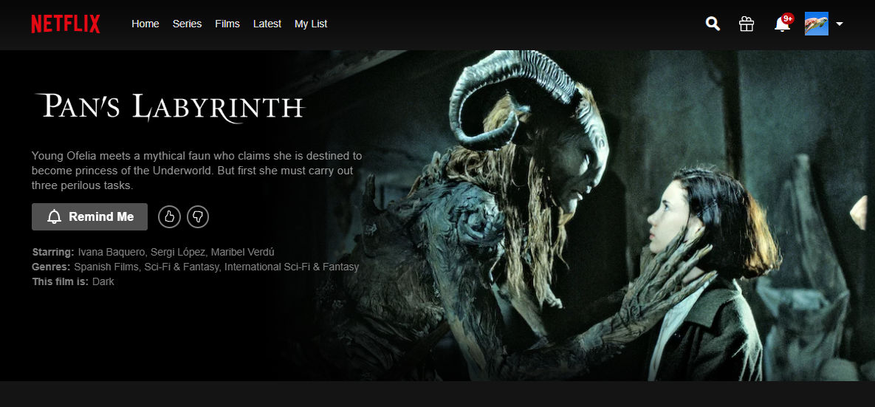
In 1944 Francoist Spain, Ofelia, fascinated with fairy-tales, is sent with her pregnant mother to live with her new stepfather, a ruthless captain of the Spanish Nationalist army. During the night, she meets a fairy who takes her to an old faun in the centre of the labyrinth. The Faun tells Ofelia that she is a princess and, to prove that she is the true princess, she has to complete three gruesome tasks. If she fails, she will never see her real father, the king, again.
Watch Pan’s Labyrinth on NETFLIX

LA CASA DE BERNARDA ALBA
The House of Bernarda Alba is a brilliant and disturbing play by Federico García Lorca who was murdered by Spanish fascists in 1936. It is a timely reminder that repressive patriarchal societies were a reality in Spain and that there is still a long way before liberty and justice are realised everywhere and for everyone.
Watch Michael Sommer and his Playmobil cast present a compact and entertaining summary of this great play.
DISCLAIMER: WATCHING THIS VIDEO DOES NOT REPLACE STUDYING THE ORIGINAL IN CLASS
(8 minutes)
https://www.youtube.com/watch?v=3G74hKsCxVw

STAYING FLUENT
To improve your understanding of spoken Spanish:
- Enrol free of charge on an Open University Open Learn Course.
Intermediate Spanish: Understanding spoken Spanish.
https://www.open.edu/openlearn/languages/intermediate-spanish-understanding-spoken-spanish/content-section-0?active-tab=description-tab

- Spanish is a colourful language which beautifully expresses feelings of revenge and grief to passion and longing. Apart from the fun songs about love and partying we all like to sing along to, many of the most compelling songs about rebellion, revolution and resilience are beautifully sung in Spanish. Try some of the following songs:

Rosalía – Malamente
https://youtu.be/Rht7rBHuXW8

Orishas – Despójame
https://youtu.be/Rs3f6n2oqQc

Álvaro Soler – El Mismo Sol
https://youtu.be/aNHwNreDp3A

Bebe – Malo
https://youtu.be/90GqAf3zJ8s

Kchiporros – Negrita
https://youtu.be/SIrBbeIw800

Amanitas – Me desvelo
https://youtu.be/Tp6A89ROBCM
Pedrina – Inevitable
https://youtu.be/kCXRJat-aBo

Lele Pons – Celoso
https://youtu.be/oXm2AuqwPlc

Jessie Reyez – Sola
https://youtu.be/mHlsuFMVJjs

Los Mesoneros – Dime Cómo Tú Quieras
https://youtu.be/bnrN7mMIMvI

- Stream Spanish language films and TV series via Netflix or Amazon Prime

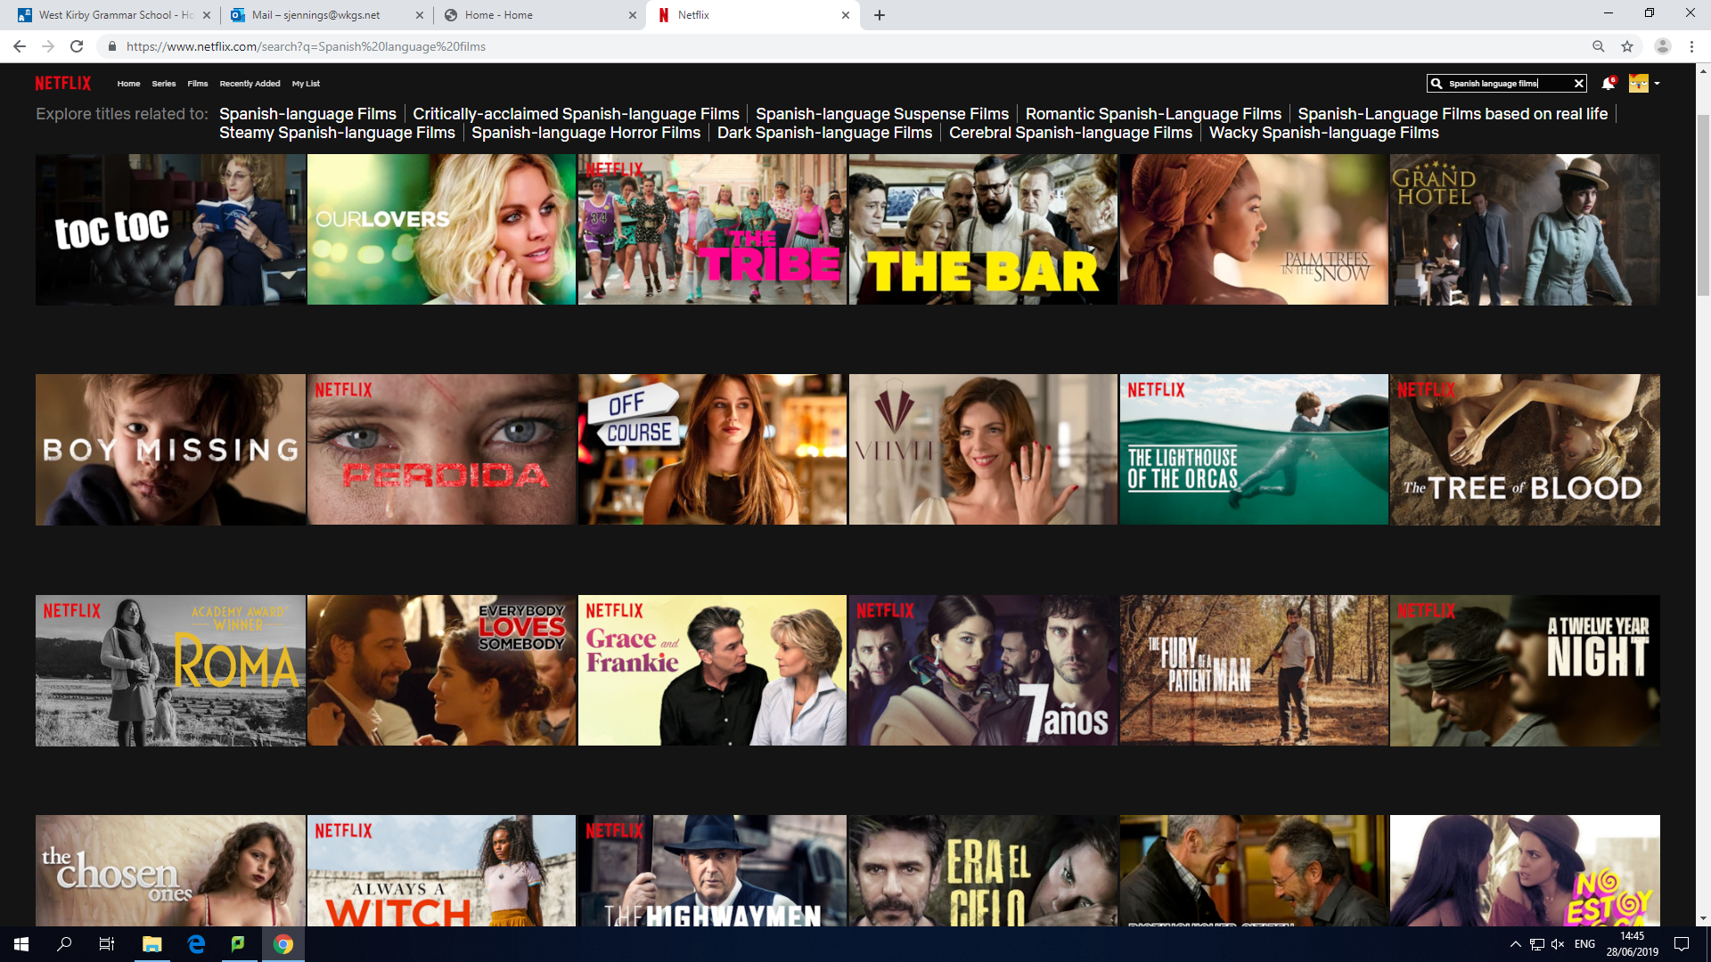

- Speaking Slang With Antonio Banderas
https://www.youtube.com/watch?v=eZ0vxQ3uJCU

CURRENT AFFAIRS

Language learning through current affairs enables you to keep up with current events in Spanish speaking countries and to learn the language at the same time.

Listen to the news read to you slowly in Spanish with Linguistica 360.
https://www.linguistica360.com/

BBC Mundo offers the day’s new stories in Spanish.

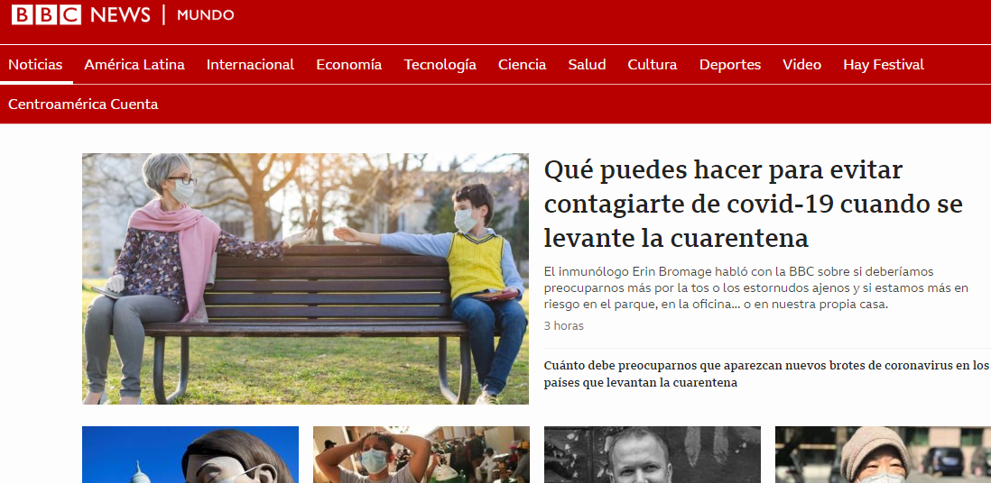

https://www.bbc.com/mundo

ART

Experience the Picasso and Paper exhibition at the Royal Academy with this video tour. Picasso did not just draw on paper, he tore it, burnt it, and made it three-dimensional. This exhibition brings together more than 300 works on paper spanning the artist's 80-year career.

https://www.youtube.com/watch?v=oOOY6GbV9Ks

Visit El Museo Nacional Centro de Arte Reina Sofía online with Google Arts and Culture

View Picasso’s Guernica, his epic painting which commemorates the bombing of the Basque town of Guernica during the Spanish Civil War.

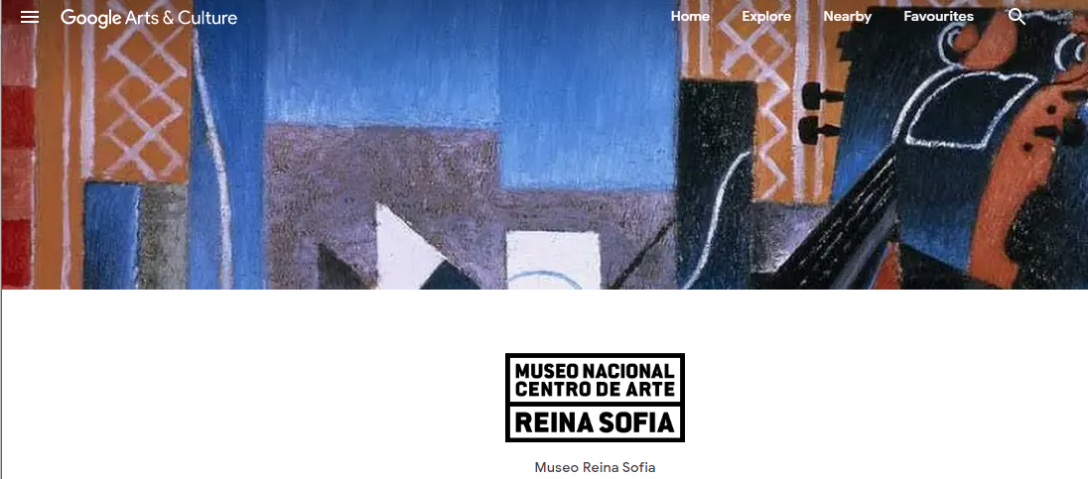

https://artsandculture.google.com/partner/museo-reina-sofia

Visit El Museo Thyssen Bornemisza online with Google Arts and Culture
https://artsandculture.google.com/partner/museo-thyssen-bornemisza

Visit El Museo Guggenheim online with Google Arts and Culture

https://artsandculture.google.com/project/guggenheim-bilbao

Research one of the following artists from the Hispanic World:

- El Greco
- Diego Velázquez
- Francisco Goya
- Francisco de Zurburán
- Joaquín Sorolla
- Pablo Picasso
- Joan Miró
- Salvador Dalí
- Antoni Tàpies
- Diego Rivera
- Frida Kahlo
- Leonora Carrington

